**Explore Anatomical Insights and body dynamics in dance (Kuchipudi) through Yoga**

Lakshmi Aparna Logisetti

Kuchipudi, University of Silicon Andhra

GKD507

Anupama Kailash

10th Mar 2024

Table of Contents

Anatomical Body Insights - Yoga – Kuchipudi 3

Chapter 2.1: Anatomical Foundations of Dance 3

**Overview of Body Movements in Kuchipudi** 4

**Exploration of Physical Anatomy with Dance Movements** 6

**Exploring of Yoga Principles and its connection to Dance** 17

**Theoretical Framework** 22

Chapter 2.2: Yogic Influence on Body Dynamics 23

**Understanding the Body through Yoga** 24

**Impact of Yoga on Physical Awareness** 26

**Application of Yogic Principles in Dance (Kuchipudi)** 29

Chapter 2.3: Techniques and Practical Applications for Integration 31

**Techniques of Yoga to Integrate into Dance Practice** 32

**Commonalities for Integration - Yoga and Dance** 33

**Practical Application - Cultivating Aramandi Precision through Yoga Integration** 34

**Case Studies on Performers' Experiences** 46

**Why to integrate yoga techniques to dance?** 49

References 50

**Chapter One**

# **Anatomical Body Insights - Yoga – Kuchipudi**

## **Chapter 2.1: Anatomical Foundations of Dance**

Dance is the embodiment of rhythmic and expressive body movement, often orchestrated into a cohesive pattern. It's a form of artistic expression that transcends cultural boundaries and resonates deeply with human experience. The fundamental steps of dance are rooted in the basic movements of mankind, such as walking, running, jumping, hopping, and skipping. Over time, these movements have evolved into traditional dance steps, which are often stylized and incorporated into various dance forms including Kuchipudi.

Anatomy and the study of body movements play a crucial role in the creation of dance. Each limb, muscle, and organ are meticulously researched and studied, with a deep understanding of biomechanics and kinetics. This knowledge allows dancers to execute movements with precision, grace, and fluidity, enhancing the overall aesthetic and emotional impact of their performance

In the ancient Indian text NatyaShastra, the oldest known treatise on performing arts, detailed descriptions of body movements, known as "Angika Abhinaya," are provided. Every aspect of the body, from the placement of the fingers to the tilt of the head, is meticulously analyzed and codified to create a comprehensive system of movement in dance.

Bharata. (n.d.). Nāṭyaśāstra (Chapter VIII, Chapter IX, Chapter X, Chapter XI)

### **Overview of Body Movements in Kuchipudi**

Bharata in NatyaShastra have profound understanding of the human anatomy in relation to dance. Before commencing any dance performance, Bharata meticulously detailed the correct posture of the body, focusing on the alignment of various anatomical elements such as the spine, torso, shoulders, wrists, elbows, knees, and feet. This body preparation, known as "Saushthavam", emphasized the importance of proper alignment and balance, ensuring that dancers could execute movements with grace, precision, and fluidity.

Sauṣṭhava is emphasized for those engaging in exercises within aṅgahāras, as it plays a crucial role in enhancing the beauty of both dramatic and dance performances. Without sauṣṭhava, the limbs lack the radiance necessary to captivate an audience effectively. The proper presentation of sauṣṭhava involves maintaining a state of stillness, relaxation, and balanced posture, avoiding extremes of either excessive upright or overly bent positions. Achieving sauṣṭhava requires ensuring that the waist, ears, elbows, shoulders, and head are naturally aligned, known as Sama, while also lifting the chest. In essence, sauṣṭhava embodies a harmonious balance and ease of movement, essential for conveying beauty and authenticity in performance art (Bharata. (n.d.). Nāṭyaśāstra (Chapter X, Verse 88)).

*Kāti Karṇa samāyathra*

*Kūrpara aṃśa śīrasthathā*

*Samunnatham ūraschaiva*

*Śauṣṭhavam nāma tath bhavet*

Bharata. (n.d.). Nāṭyaśāstra (Chapter IV, Verse 60). (Sanskrit text)

By incorporating anatomical principles into the practice of dance, Bharata Muni laid the foundation for a holistic approach to performance art, where physical alignment and expressive movement harmoniously coalesce to create a captivating and enriching experience for both dancers and spectators alike. Below are the different stances and postures proposed by Bharata in the text.

**Mandala (Elegant Poses and Stances)** : At the core of Kuchipudi lies its graceful postures and stances, referred to as mandala. Dancers effortlessly shift between various positions, exuding a sense of equilibrium and composure. These poised poses serve as the foundation of the choreography, imbuing performances with refinement and visual allure.

**Bhramaris(Graceful Spinning)** : A hallmark of Kuchipudi is its agile spins and rotations, known as bhramaris. Dancers execute these swift rotations with finesse and accuracy, injecting a dynamic dimension into their performances. The bhramaris symbolize the fluidity of movement and provide captivating interludes within the choreography.

**Nritta Hasta (Pure Dance Hand Gestures)** : Nritta hasta involves the use of hand gestures primarily for pure dance sequences. Dancer’s craft geometric patterns and rhythmic formations with their hands, enhancing the visual appeal of the performances. Abhinaya Hasta: Expressive Hand Gestures

**Abhinaya Hasta (Expressive Hand Gestures)** : Hand gestures, known as "Hasta Mudras," play a pivotal role in Kuchipudi. Dancers use a rich vocabulary of mudras to convey specific meanings, emotions, or objects, adding a layer of sophistication and symbolism to their performances.

**Natya (Expressive Facial Movements)** : Kuchipudi places a strong emphasis on facial expressions, known as "Abhinaya." Dancers skillfully convey a myriad of emotions, characters, and narratives through the subtle movements of their eyes, eyebrows, and facial muscles.

**Shiro Bheda (Fluid Head Movements)** : The dance form incorporates a variety of head movements, from gentle tilting to intricate turns and nods. These movements not only add a layer of expressiveness but also contribute to the overall fluidity and grace of the performance.

**Griva Bheda(Artistic Neck Movements)** : The neck movements in Kuchipudi complement the head movements, adding elegance and refinement to the dancer's portrayal. These movements are crucial in creating a harmonious flow and enhancing the aesthetic appeal of the performance.

**Kati Bheda (Dynamic Torso Movements)** : Kuchipudi involves intricate movements of the torso, including bending and twisting. These dynamic torso movements contribute to the dance's dynamism, allowing the dancer to convey a wide range of emotions and characters with finesse.

**Pada Bheda (Rhythmic Footwork)** : One of the distinguishing features of Kuchipudi is its intricate footwork, known as "Adugulu." Dancers create rhythmic patterns using their feet, producing a melodic and percussive element that enhances the overall auditory experience of the dance.

**Ardhamandali (Semi-Seated Posture)** : Ardhamandali stands as a distinctive posture in Kuchipudi, where dancers adopt a semi-seated stance with one leg bent and the other extended. This posture underscores the dancer’s suppleness and poise, facilitating seamless transitions between movements and poses, enriching the overall aesthetic of the performance.

Mastering the body movements of Kuchipudi requires rigorous training and precise control, as well as a heightened awareness of every subtle gesture and expression. It is through this meticulous attention to detail and dedication to refining body movement that dancers can truly embody the essence of this rich and captivating dance form

### **Exploration of Physical Anatomy with Dance Movements**

Exploration of physical anatomy in terms of body movement delves into the intricate relationship between the human body's structure and its capability for movement. This exploration involves a comprehensive study of the musculoskeletal system, understanding how bones, muscles, joints, and connective tissues work together to produce various movements. By dissecting the body's anatomical components, dancers and movement practitioners gain insights into biomechanics, kinetics, and proprioception—the body's sense of its own position and movement in space. Such exploration enables dancers to refine their technique, optimize efficiency, prevent injuries, and enhance expressiveness in their performances. Additionally, a deep understanding of physical anatomy empowers dancers to consciously manipulate their bodies, unlocking new possibilities for artistic expression and creative movement exploration. Through continuous exploration and refinement of physical anatomy, dancers expand their movement vocabulary, enriching their artistic practice and deepening their connection with the transformative power of movement.

The fluidity of hand gestures, known as hasta mudras, relies on the intricate coordination of muscles and tendons within the hands and wrists. Dancers must develop strength, flexibility, and control in these anatomical structures to convey subtle nuances of emotion and narrative through their gestures. Similarly, the rhythmic footwork characteristic of Kuchipudi hinges on the coordination and strength of muscles and ligaments in the feet, ankles, and lower legs. By understanding the anatomical mechanics of their lower extremities, dancers can execute intricate foot patterns with agility and precision, enhancing the rhythmic complexity of their performances. By cultivating awareness of spinal alignment, pelvic positioning, and core engagement, dancers can achieve a strong and stable foundation from which to execute dynamic movements with ease.

An understanding of anatomical principles empowers dancers to prevent injuries and optimize their physical conditioning regimen. By recognizing potential areas of weakness or imbalance, dancers can implement targeted exercises and stretches to enhance muscular strength, flexibility, and endurance, thereby minimizing the risk of injury and maximizing performance potential.

In Physical Anatomy, fundamental notion is, there is interconnectedness and interdependence among all elements. Any disruption or misalignment in one area of the body reverberates throughout the entire organism. Below are the basic anatomy movement of body which compares to posture or stances of Kuchipudi dance (reference to Nāṭyaśāstra)

Before delving in to Anatomy, below are the different planes and axis to describe the body and movement:

**Sagittal Plane:** Divides the body into left and right halves, enabling flexion and extension movements along a front-to-back axis.

**Coronal Plane:** Divides the body into front and back halves, facilitating abduction and adduction movements along a side-to-side axis.

**Transverse/Axial Plane:** Divides the body into upper and lower halves, allowing rotational movements like internal and external rotation along a horizontal axis.

**Sagittal Axis:** An imaginary line perpendicular to the sagittal plane, facilitating movements in the frontal plane such as abduction and adduction.

**Coronal Axis:** An imaginary line perpendicular to the coronal plane, enabling movements in the sagittal plane like flexion and extension.

**Vertical Axis:** An imaginary line passing vertically through the body, facilitating rotational movements in the transverse plane such as internal and external rotation.

**Flexion and Extension**: When we mention flexion and extension, we typically describe these movements as they occur around the coronal axis and within the sagittal plane. Flexion involves reducing the angle of a joint, while extension involves returning the joint angle to its resting anatomical position.

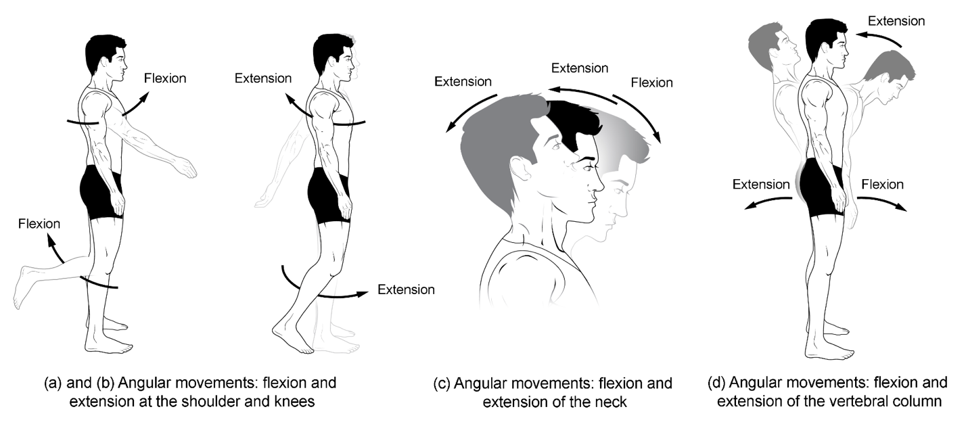

**Figure 1. Flexion and extension.** (a)–(b) Flexion and extension motions are in the sagittal (anterior–posterior) plane of motion. These movements take place at the shoulder, hip, elbow, knee, wrist, metacarpophalangeal, metatarsophalangeal, and interphalangeal joints. (c)–(d) Anterior bending of the head or vertebral column is flexion, while any posterior-going movement is extension.

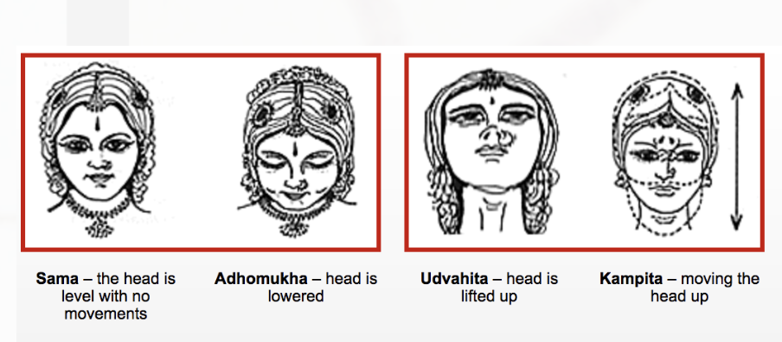

**Figure 2.**Head Movements showing flexion and extension of the neck

**.** 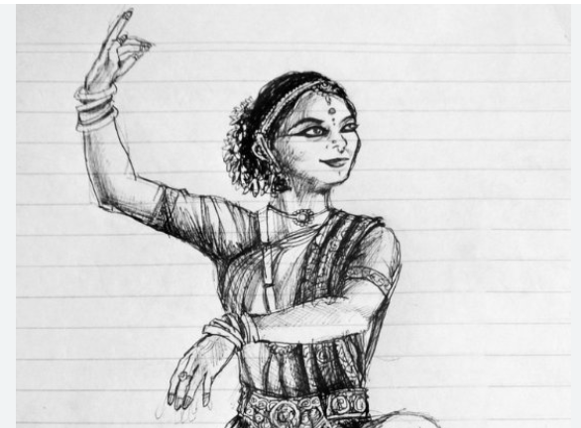

**Figure 3.**Flexion of hand in a dance posture

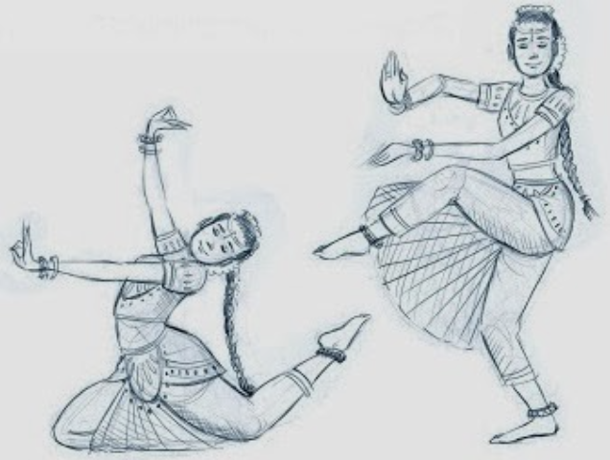

**Figure 4.**Angular Movements in a dance posture

#### **Abduction, adduction and Circumduction:** Abduction and adduction involve movements around a sagittal axis within the coronal plane. Abduction entails moving a body part away from its natural anatomical position in the coronal plane, while adduction involves bringing it back to its original resting position (which may include 'hyperadduction'). Circumduction is a complex motion exclusive to ball-and-socket joints, capable of executing various types of movements.

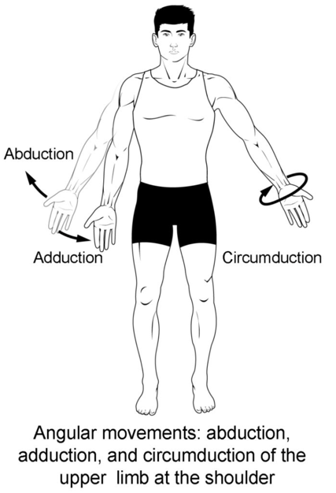

**Figure 5.** Abduction, adduction, and circumduction.

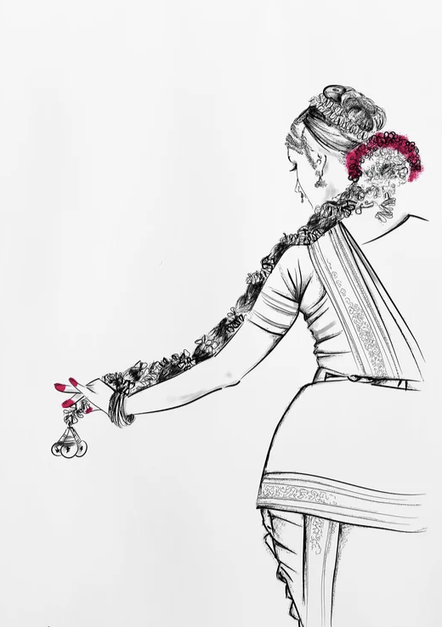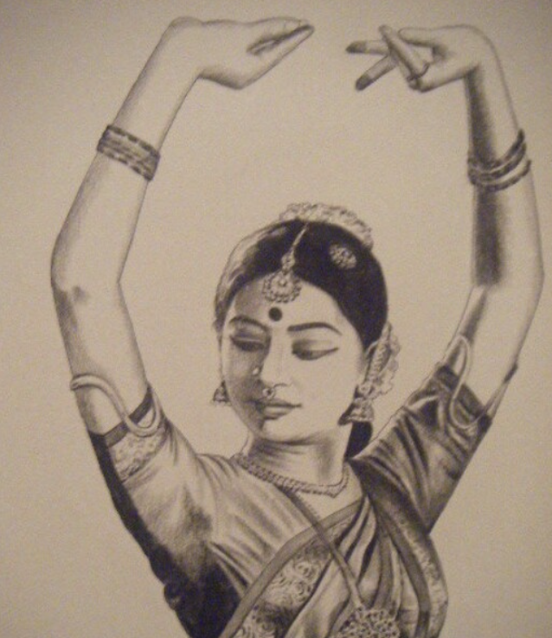

**Figure 6.** Beautiful gesture of holding Jada (braided hair) showing Abduction movement. Also shows the circumduction with wrist movement in both poses

**Elevation and depression, Opposition and re-position** : Elevation signifies lifting, while depression denotes lowering. These actions are limited to specific body regions and arise from movement within the coronal plane. Opposition and reposition are specialized movements exclusive to the human hand, enabling fine dexterity for grasping objects. These actions occur primarily at the thumb and little finger, each possessing dedicated muscles for precise control. Opposition involves bringing the pads of the thumb and little finger together at the hand's midline. Notably, the thumb can oppose each of the other fingers individually on the same hand. Repositioning, conversely, entails returning the thumb and little (or other) fingers to their resting anatomical position.

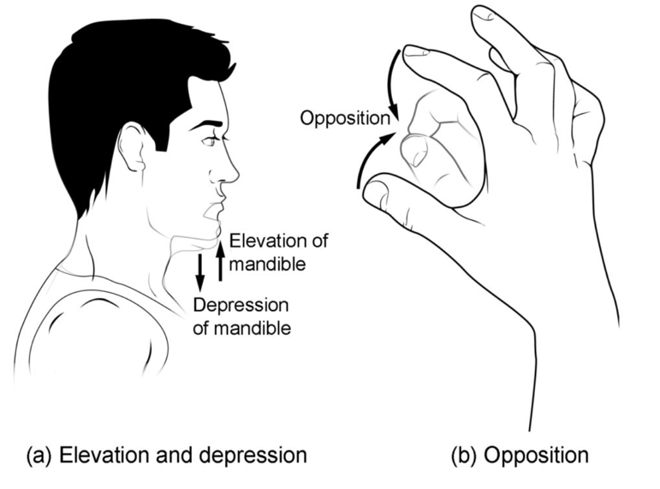

**Figure 7. Depression, elevation, and opposition.** (a) Depression of the mandible opens the mouth, while elevation closes it. (b) Opposition of the thumb brings the tip of the thumb into contact with the tip of the fingers of the same hand and reposition brings the thumb back next to the index finger.

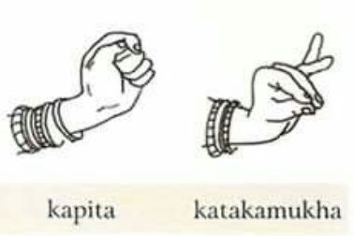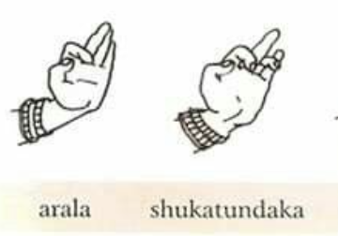

**Figure 8.** SingleHand gestures representing elevation and depression of fingers Anatomy

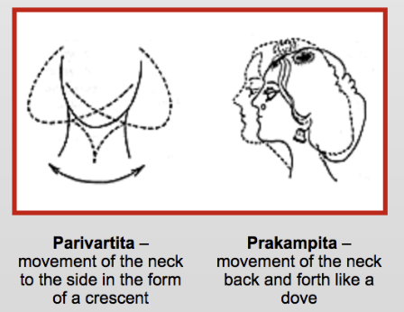

**Figure 9.** Head Movement Prakampitha showing the elevation and depression movement

**Rotation** : Rotation involves movements around the longitudinal axis within the transverse plane. Internal rotation entails rotating a joint towards the midline, while external rotation involves rotating a joint away from the midline.

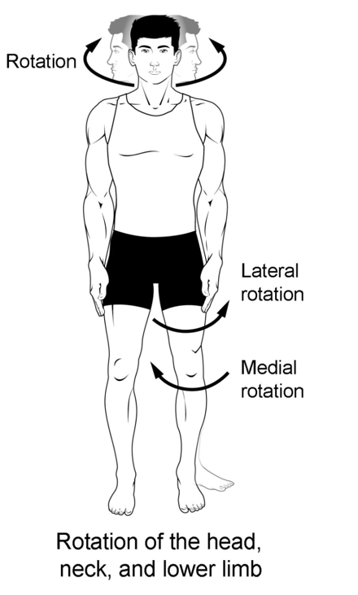

**Figure 10.** Rotation

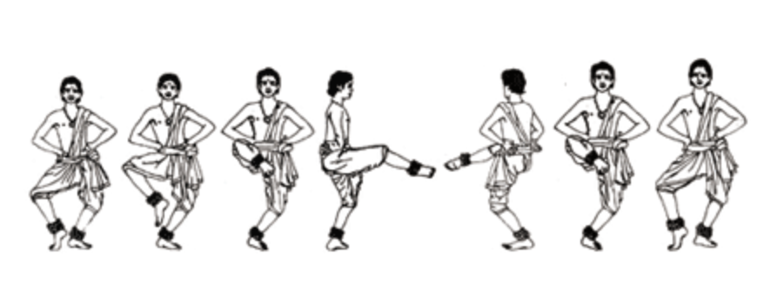

**Figure 11.** Akasiki Charis showing Apakrantha which has movement sideways either in clockwise or anticlockwise direction representing Rotation Anatomy

**Pronation and supination** : Pronation and supination take place primarily at pivot joints, such as the radiohumeral joint (joint between the radius and the humerus bones in the forearm) where the radius and ulna join via the interosseous membrane.

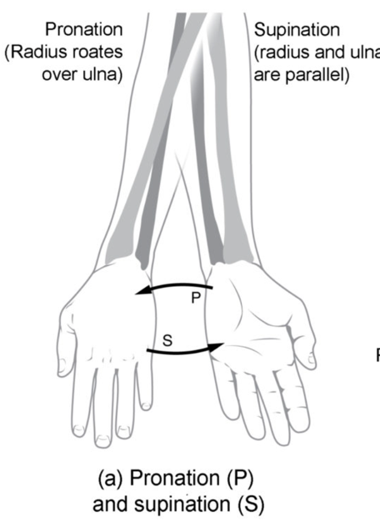

**Figure 12. Supination and pronation.** Supination of the forearm turns the hand to the palm forward position in which the radius and ulna are parallel, while forearm pronation turns the hand to the palm backward position in which the radius crosses over the ulna to form an “X.”

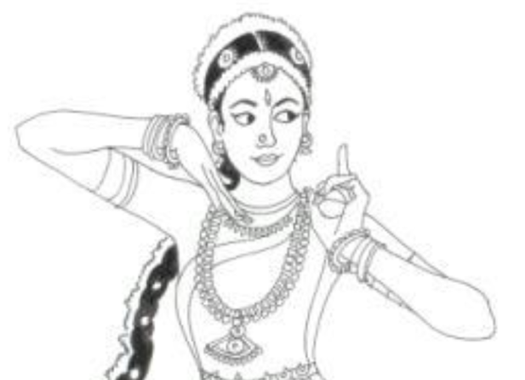

**Figure 13.** Anchita and Kunchita palm movement usage in a dance posture showcasing the Anatomy of Supination and pronation

**Dorsiflexion and plantarflexion** : The foot exhibits four distinct movements. The initial two, dorsiflexion and plantarflexion, pertain to the foot's motion around the coronal axis within the sagittal plane. Dorsiflexion involves bringing the dorsum (back) of the foot toward the tibia, initiating a motion where the toes begin to point upwards, contributing to high ankle stability. Conversely, plantarflexion entails extending the foot away from the tibia and downward towards the ground.

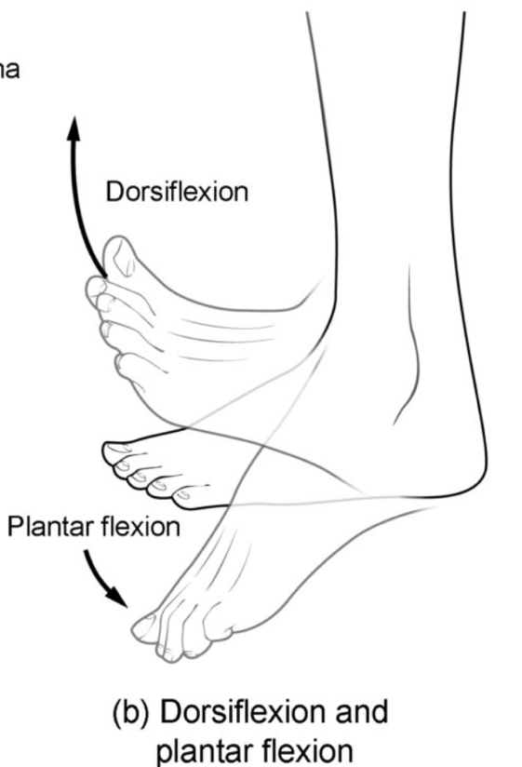

**Figure 14.** Dorsiflexion of the foot at the ankle joint moves the top of the foot toward the leg, while plantar flexion lifts the heel and points the toes

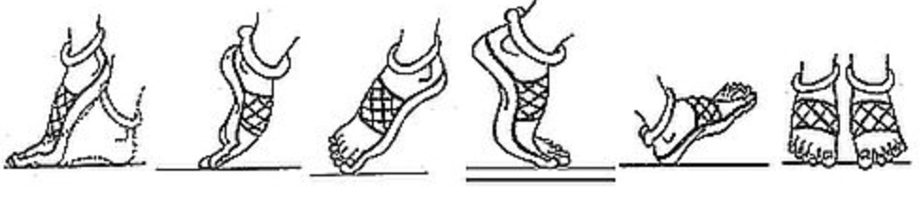

**Figure 15.** Pada Bedha inclusing Anchita and Kunchita postures representing Dorsiflexion of the foot and plantar flexion lifts the heel and points the toe

**Eversion and inversion** : The foot presents another pair of distinctive movements: eversion and inversion. These actions revolve around the sagittal axis within the coronal plane. Eversion involves outwardly turning the soles of the feet away from the body's midline. Conversely, inversion entails inwardly turning the soles of the feet toward the body's midline and each other.

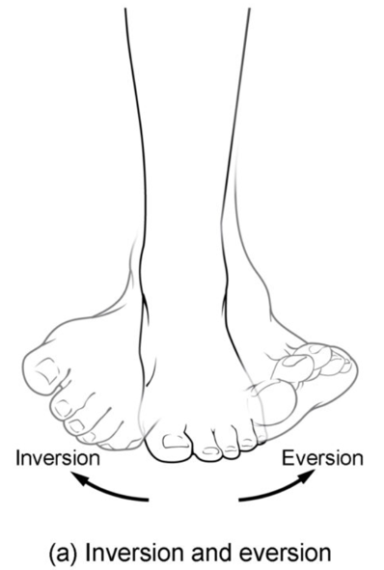

**Figure 16. Inversion, eversion.** Eversion of the foot moves the bottom (sole) of the foot away from the midline of the body, while foot inversion faces the sole toward the midline.

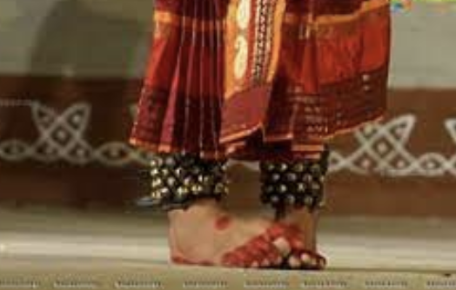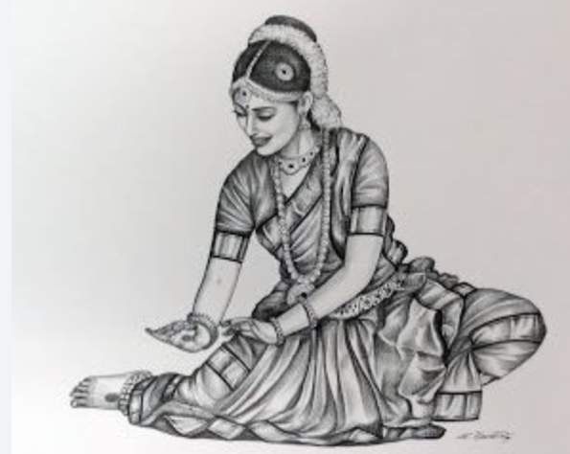

**Figure 17.** Kuchipudi foot work in Tarangam Item which represents the Inversion and in second picture(Black and White) shows the posture which uses Eversion of foot

**Protraction and retraction** : Protraction and retraction manifest in two significant regions of the body: the scapula and the mandible. Protraction involves the act of protruding or extending outward, while retraction entails bringing together or pulling inward.

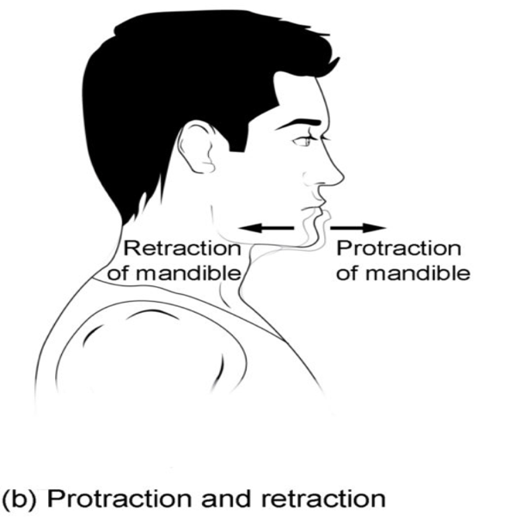

**Figure 18. Protraction, and retraction.**  Protraction of the mandible pushes the chin forward, and retraction pulls the chin back.

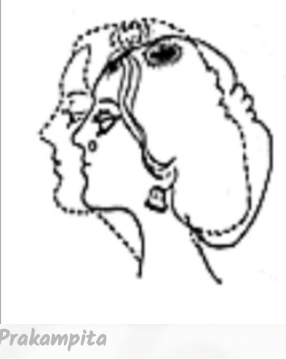

**Figure 19.** Prakampitha in Neck Movement showing the Protraction, and retraction movement

### **Exploring of Yoga Principles and its connection to Dance**

The integration of yoga principles into various aspects of life, including physical exercise, mental well-being, and spiritual growth, has become increasingly popular in contemporary society. Yoga, an ancient practice originating in India, offers a comprehensive system for harmonizing the body, mind, and spirit. Its principles in terms of physical postures, encompassing breath control, meditation, ethical guidelines, and philosophical teachings are very much closer to dance, specially dances that follows Natyasastra. These yoga principles are applied to the body, balance, breath, techniques, and flow, illuminating their transformative potential in enhancing overall health and wellness. In Hindu mythology, Shiva is revered as Yogiraj, the ultimate yogi, credited with the creation of over 840,000 asanas, including those practiced in modern hatha yoga. While these mythic narratives may not resonate with cultural outsiders in a literal sense, they hold profound significance for dancers in India, who honor the divine origins of their art forms. According to legend, the sage Bharata received the revelation of dance from divine sources, which he documented in the NatyaShastra. Similarly, Patanjali's Yoga Sutra, another foundational text on yoga, is believed to have been inspired by an encounter with Nataraja, the cosmic dancer form of Shiva.

**Body** : Yoga emphasizes the importance of cultivating awareness and connection with the physical body. Through yoga postures (asanas), individuals develop strength, flexibility, and alignment, fostering a sense of vitality and well-being. By tuning into bodily sensations and exploring the body's capabilities, practitioners deepen their understanding of themselves and their physical potential. In dance forms derived from the Natyasastra, such as Bharatanatyam, Kuchipudi, and Odissi, the body is considered a sacred vessel for artistic expression and spiritual embodiment. Similar to yoga, these dance traditions place great emphasis on cultivating awareness and connection with the physical body. Just like in yoga postures (asanas), dancers engage in specific movements and poses that challenge their physical capabilities, requiring them to maintain proper alignment and posture. Dancers tune into bodily sensations and explore the body's capabilities to deepen their understanding of themselves and their artistry. They learn to listen to their bodies, discerning subtle nuances in movement quality, rhythm, and expression. This heightened bodily awareness allows dancers to embody characters, convey stories, and evoke emotions with authenticity and depth.

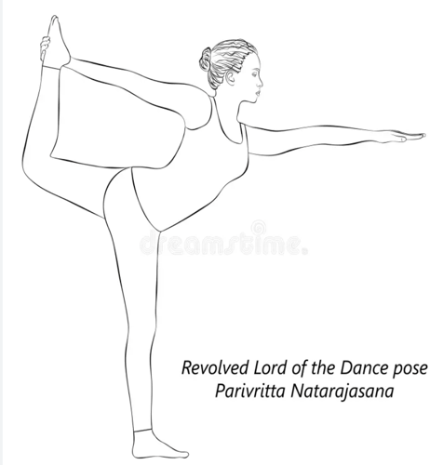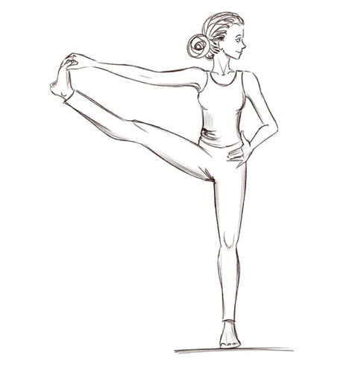

**Figure 20.** Two of distinct poses-revolved dancer, Toe hold in Yoga

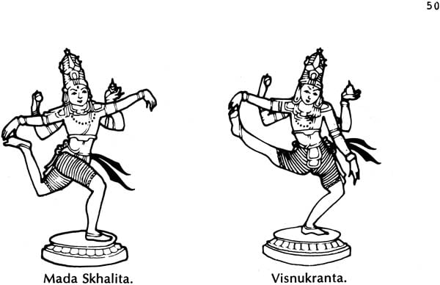

**Figure 21.** Two of distinct Karana’s Mada Skhalita and Visnukranta from Natyasastra representing match with Toe hold and revolved dancer poses of Yoga

**Balance** : Balance in yoga extends beyond physical equilibrium to encompass mental, emotional, and energetic balance. Through practices such as standing balances and inversions, individuals cultivate physical steadiness and poise, enhancing proprioception and coordination. Additionally, yoga encourages the cultivation of inner balance by harmonizing opposing forces such as effort and surrender, tension and relaxation, and activity and rest. In Kuchipudi, balance is a multifaceted concept that extends beyond physical stability to encompass mental, emotional, and energetic equilibrium. Similar to yoga, dancers strive to cultivate harmony and poise in various aspects of their practice. Dancers needs to maintain stability and control while transitioning between different postures and gestures. Standing balances, where the dancer maintains a steady position on one foot while performing intricate hand movements or spins, are particularly demanding and require exceptional concentration and strength.

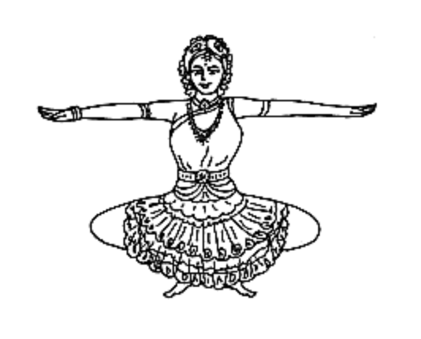 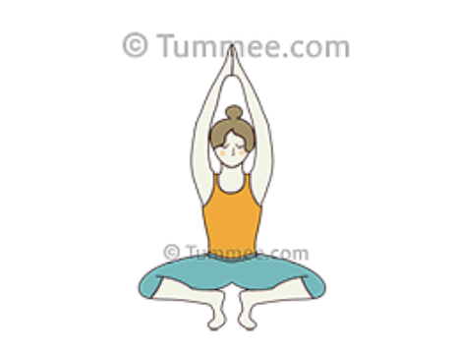

**Figure 22.** One of the Mandala from Kuchipudi repertoire which matches to wide leg toe stand practice in Yoga

**Breath** : Breath awareness is integral to yoga practice, serving as a bridge between body and mind. Through conscious breathing techniques (pranayama), individuals regulate their breath to calm the mind, energize the body, and deepen their awareness of the present moment. By syncing breath with movement in yoga sequences, practitioners enhance the flow of prana (life force energy), promoting balance and vitality throughout the body-mind system. In dance, Breath is a powerful tool for conveying emotion and expression. Dancers modulate their breath to evoke different moods and sentiments, from joy and exuberance to sorrow and longing. By controlling the pace, depth, and intensity of their breath, dancers infuse their movements with nuanced emotion and authenticity, captivating audiences with their storytelling prowess. Breath serves as a vehicle for managing energy levels and sustaining endurance during extended dance sequences. Dancers learn to breathe deeply and evenly to optimize oxygen intake, supporting their physical stamina and vitality on stage. Conscious breathing techniques help dancers maintain a sense of calm and focus, even during demanding choreography or high-energy performances.

**Techniques**: Yoga encompasses a wide range of techniques aimed at promoting physical, mental, and spiritual well-being. These techniques include yoga postures (asanas) to stretch and strengthen the body, breathing exercises (pranayama) to regulate the breath and calm the mind, meditation practices to cultivate mindfulness and inner peace, and relaxation techniques to release tension and promote deep rest. By incorporating these techniques into their practice, individuals harness the transformative power of yoga to enhance their overall health and vitality. Similarly, dances following NatyaShastra repertoire follow the Techniques proposed by Bharata to prepare the dancers body before starting. This is called Śauṣṭhavam which is explained in sub section

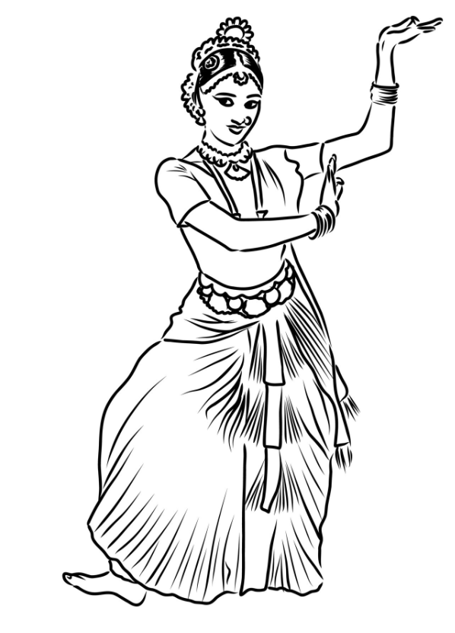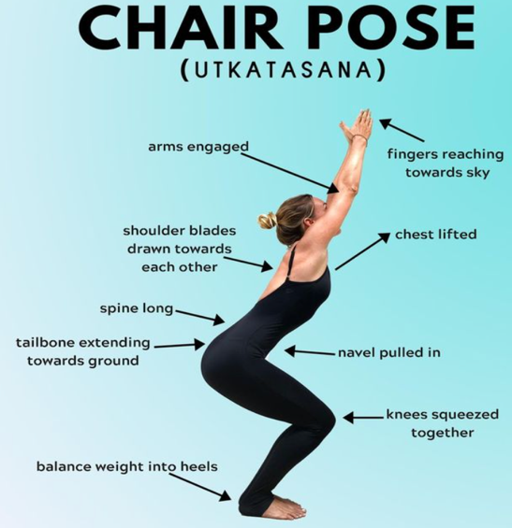

**Figure 23.** In these pictures, one of the techniques used in this dance movement is to shift weight in heels (Typically we see in ‘Digi Digi’ Adugulu) and similar technique is used to do Chair pose in Yoga. And these compliments each other because of similar body posture

**Flow**: Flow refers to the seamless integration of movement, breath, and awareness in yoga practice as well as dance. Flow-based yoga styles such as Vinyasa and Ashtanga emphasize the fluid transition between poses, creating a dynamic and meditative experience. Through conscious movement and breath awareness, practitioners enter a state of flow where they feel fully immersed in the present moment, experiencing a sense of grace, ease, and inner harmony. Flow yoga encourages individuals to let go of expectations and surrender to the natural rhythm of the practice, allowing for greater freedom of expression and self-discovery. Similarly, dancers engage in intricate choreography that requires precise timing and coordination. Flow is achieved as dancers effortlessly transition between steps, gestures, and expressions, guided by the rhythm of their breath and the music. Each movement flows into the next with grace and fluidity, creating a sense of continuity and coherence in the performance. By aligning their breath with the rhythm of the music, dancers enter a state of flow where they feel fully connected to the present moment, immersed in the beauty and expression of their artistry and involves a deep sense of surrender and letting go.

### **Theoretical Framework**

The integration of principles from Kuchipudi dance, yoga, and human anatomy forms a rich tapestry of knowledge that contributes to heightened kinesthetic awareness within dance and choreographic practice. In the book "A Yoga of Indian Classical Dance: The Yogini’s Mirror," Roxanne Gupta envisions a harmonious fusion of classical Indian dance and yoga, where these two traditions complement and enrich each other. Gupta emphasizes that yogic concentration is indispensable for executing the intricate hand gestures, postures, and movements inherent in Indian classical dance. Conversely, she highlights how the aesthetics, symmetry, and dynamic expression of dance serve to enhance the practice of yoga. In this symbiotic relationship, the disciplines of dance and yoga intertwine, mutually benefiting practitioners and deepening their understanding of both art forms.

**Integration of Dance Theory**: Dance theory serves as the foundation for understanding the artistic and technical aspects of dance. By incorporating concepts such as choreography, movement dynamics, and performance analysis, dancers gain insights into the aesthetic principles and cultural contexts of various dance forms. This knowledge enhances their creative expression and interpretative abilities, enabling them to convey narratives, emotions, and themes through movement. Additionally, dance theory provides a framework for refining technique, improving movement quality, and developing stage presence. Dancers can apply principles such as spatial awareness, rhythm, and gesture to enhance their performances and captivate audiences with their artistry.

**Application of Yogic Philosophy**: Yogic philosophy offers profound insights into the mind-body connection, consciousness, and spiritual growth. By integrating yogic principles such as union (yoga), balance (sattva), and breath control (pranayama), dancers cultivate a deeper understanding of their physical, mental, and emotional well-being. Practices such as meditation, mindfulness, and ethical living (yamas and niyamas) promote self-awareness, emotional resilience, and inner peace, providing dancers with tools to navigate the challenges of their artistic journey. Furthermore, yogic philosophy encourages dancers to explore the spiritual dimensions of their practice, fostering a sense of connection to something greater than themselves and inspiring creative exploration and self-expression.

**Understanding of Anatomical Science**: Anatomical science provides dancers with a scientific understanding of the body's structure, function, and biomechanics. By studying anatomy, physiology, kinesiology, and biomechanics, dancers gain insights into skeletal alignment, muscular engagement, joint mechanics, and range of motion. This knowledge empowers dancers to optimize their movement practices, prevent injuries, and enhance physical performance. By applying anatomical principles such as proper alignment, muscular balance, and efficient movement patterns, dancers can improve technique, increase flexibility, and reduce the risk of overuse injuries. Additionally, anatomical science informs injury rehabilitation strategies and promotes long-term physical health and wellness for dancers.

## **Chapter 2.2: Yogic Influence on Body Dynamics**

Yoga, an ancient spiritual practice originating in India, has exerted a profound influence on various aspects of human life, including physical well-being, mental clarity, and spiritual awakening. One of the lesser-explored yet immensely significant realms of yogic influence lies in its impact on body dynamics. As practitioners engage in yoga postures (asanas), breath control (pranayama), and meditation, they undergo a transformative journey that extends beyond mere physical exercise to encompass a deepening awareness of the body's subtle energies, movement patterns, and anatomical alignment. In this exploration of "Yogic Influence on Body Dynamics," we delve into the multifaceted ways in which yoga shapes and refines the dynamic interplay of the body's structural integrity, movement efficiency, and kinesthetic awareness. Through an interdisciplinary lens that merges insights from yoga philosophy, anatomical science, and movement studies, we unravel the intricate connections between yoga practice and the dynamics of the human body, shedding light on the profound implications for physical health, performance enhancement, and holistic well-being.

“Similar to the effects of meditation, yoga is a neurological vacation – but it also awakens parts of the brain that are typically inactive during normal day-to-day activity. . . The mind becomes deeply intertwined with the body and the two become one – opening up the flow of communication.” – Morgan Garza

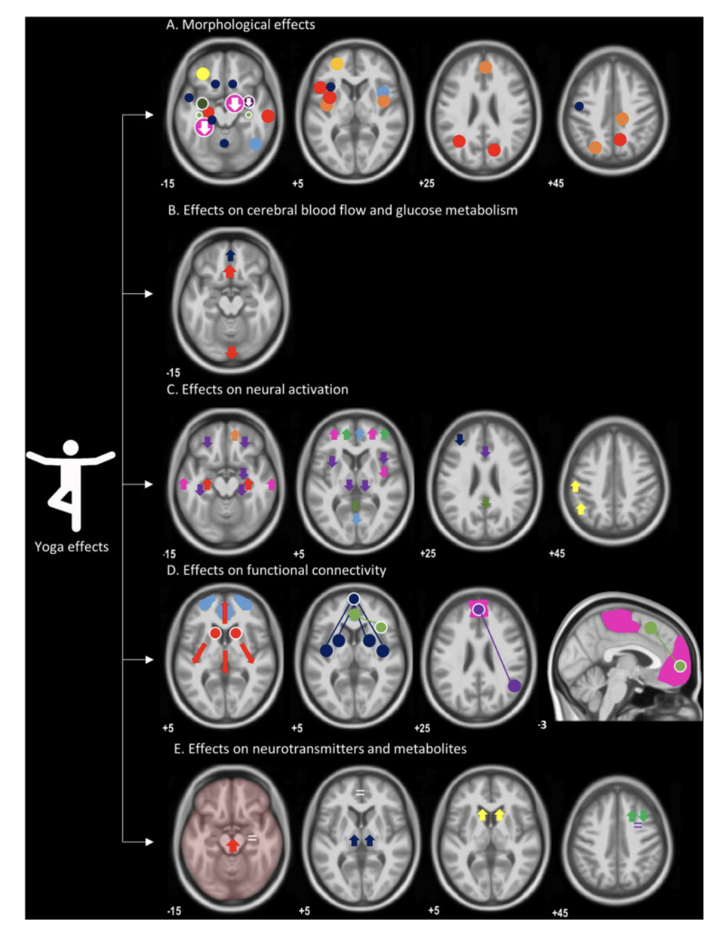

**Figure 24.** Yoga Changes the Brain to Improve Body Awareness, Attention, and Present Moment Awareness

### **Understanding the Body through Yoga**

Yoga is renowned for its ability to heighten body awareness, a phenomenon reflected in the expansion of the insular cortex observed through yoga practice. This region of the brain is intricately linked with interoceptive body awareness, aligning with the enhanced sensory perception experienced by practitioners. Moreover, yoga's impact on attentional ability is evident in the increased activation of prefrontal cortical areas, which play a crucial role in attention processing. This augmentation underscores the practice's capacity to sharpen focus and cognitive function.

Furthermore, yoga cultivates present moment awareness while mitigating mind wandering tendencies, a transformation mirrored in the heightened functional connectivity among structures of the dorsal mode network. These brain regions, associated with mind wandering and a lack of present moment awareness, exhibit increased synchronization, reflecting yoga's ability to anchor individuals in the here and now. By fostering a state of focused attention and presence, yoga facilitates a profound shift in cognitive processing, promoting greater clarity, mindfulness, and mental well-being.

Thus, at the heart of "Understanding the Body through Yoga" lies the concept of embodiment, which emphasizes the direct experience and awareness of the body in the present moment. Through asana practice, practitioners cultivate a heightened sense of somatic awareness, tuning into sensations, tensions, and subtle movements within the body. With mindful attention and breath awareness, they explore the body's sensations without judgment or attachment, fostering a deeper connection to the physical self and the present moment.

Yoga also offers a holistic framework for understanding the body's anatomy, physiology, and energetic anatomy (prana, nadis, and chakras). By studying key anatomical landmarks and energy centers, practitioners gain insights into the body's structural integrity, functional mobility, and energetic balance. Through practices such as pranayama (breath control), bandhas (energy locks), and mudras (gestures), individuals learn to channel and regulate the flow of prana (life force energy) throughout the body, promoting vitality, equilibrium, and holistic well-being.

Moreover, "Understanding the Body through Yoga" transcends the physical realm to encompass the mind-body connection and the subtle layers of consciousness. Through meditation, introspection, and self-inquiry, practitioners explore the mind-body relationship, uncovering the interconnectedness of thoughts, emotions, and bodily sensations. By cultivating mindfulness and inner presence, individuals develop a deeper understanding of how mental patterns and emotional states manifest in the body, paving the way for healing, transformation, and self-realization.

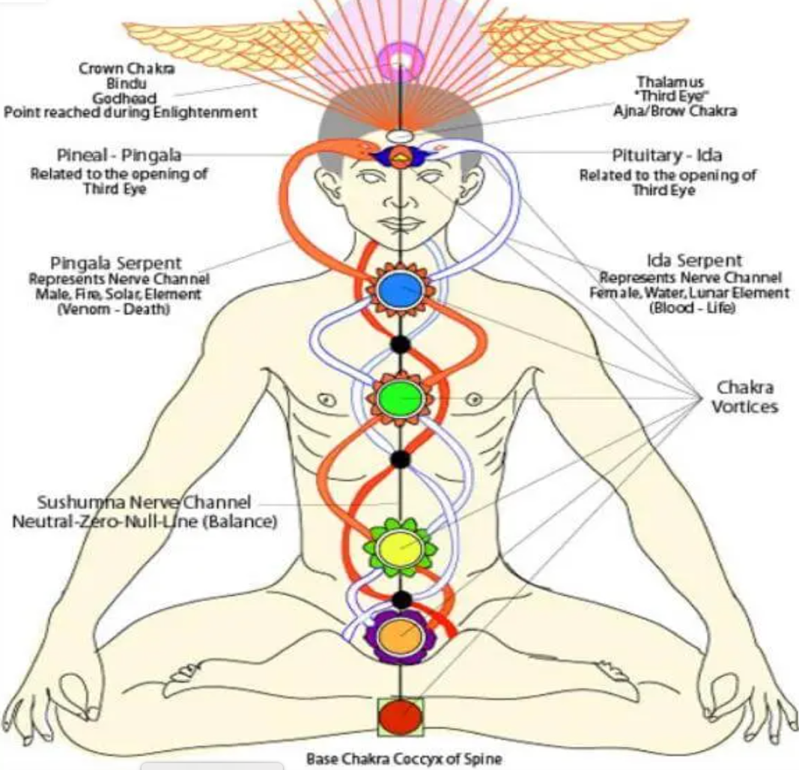

**Figure 26.** Chakra placements in Body (Bottom to Top order)

In essence, "Understanding the Body through Yoga" offers a profound exploration of the body-mind-spirit connection, inviting practitioners to embark on a journey of self-exploration, self-awareness, and self-transformation. By integrating the wisdom of yoga into their embodied experience, individuals gain invaluable insights into the holistic nature of the human body and its potential for growth, healing, and evolution.

Exploring the profound union of yoga and anatomical comprehension, this section illuminates how yogic practices serve as a gateway to a deeper understanding of the dancer's physical form.

### **Impact of Yoga on Physical Awareness**

"Impact of Yoga on Physical Awareness" delves into the transformative effects of yoga practice on developing heightened awareness of the physical body. This sub-section explores how yoga cultivates a deep sense of embodiment, proprioception, and sensitivity to subtle sensations, leading to greater physical awareness and self-understanding.

**Embodiment and Presence**: Yoga fosters a profound sense of embodiment, encouraging practitioners to inhabit their bodies fully and be present in the moment. Through asana practice, individuals develop a keen awareness of body alignment, muscular engagement, and breath synchronization, anchoring them in the present moment and fostering a sense of grounded and inner stability.

**Proprioception and Kinesthetic Awareness**: Yoga enhances proprioception, the body's innate sense of spatial orientation and movement. By practicing yoga postures that involve balance, coordination, and subtle adjustments, individuals refine their proprioceptive skills, becoming more attuned to the position and movement of their limbs in space. This heightened kinesthetic awareness enables practitioners to move with precision, grace, and efficiency, both on and off the mat.

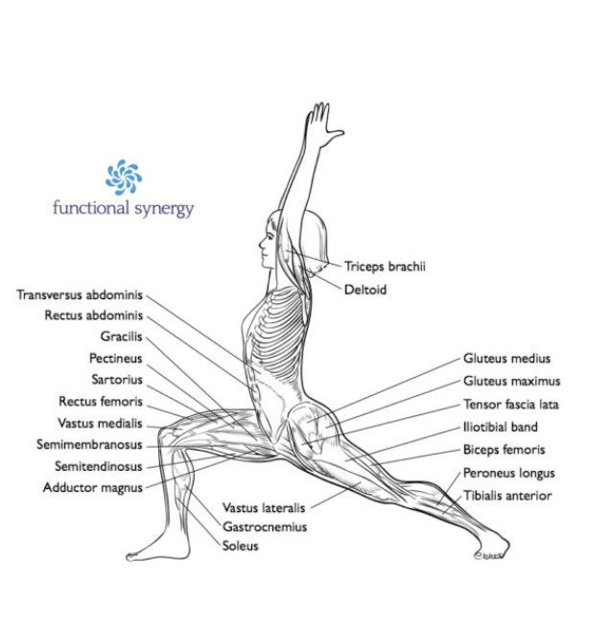

**Figure 27.** Half Moon pose showcasing the different muscle usage with respective body Anatomy

**Sensitivity to Sensations**: Yoga cultivates sensitivity to subtle sensations within the body, such as muscle tension, joint mobility, and energetic flow. Through mindful movement and breath awareness, practitioners learn to discern and explore these sensations with curiosity and non-judgmental awareness, deepening their understanding of the body's needs and limitations. This heightened sensitivity enables individuals to make informed choices in their practice, adjusting postures and movements to suit their unique anatomical structure and energetic state.

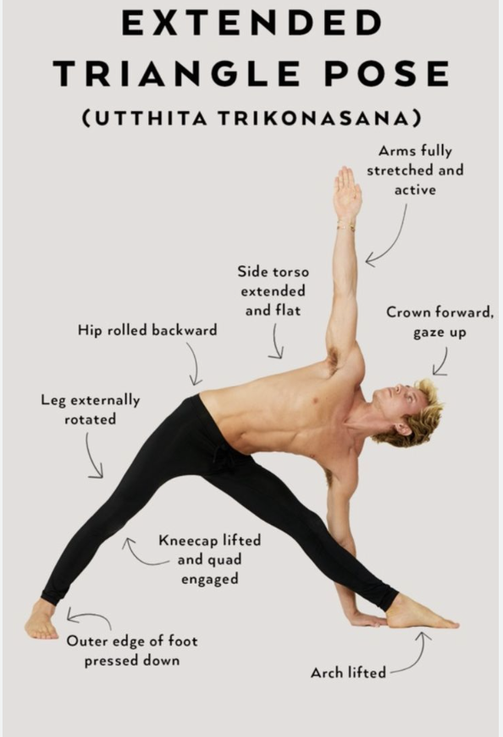

**Figure 28.** Triangle pose which shows the maintaining your balance and stability which requires engaging your core muscles Anatomy

**Integration of Mind and Body**: Yoga facilitates the integration of mind and body, fostering a holistic approach to physical awareness. Through practices such as pranayama (breath control), meditation, and mindfulness, individuals cultivate a deeper connection between their physical sensations, mental states, and emotional well-being. This integrated awareness allows practitioners to recognize the interconnectedness of their thoughts, emotions, and bodily sensations, promoting a sense of wholeness, balance, and inner harmony.

**Enhanced Self-Understanding**: Ultimately, yoga fosters enhanced self-understanding through the cultivation of physical awareness. By exploring the body's sensations, movements, and limitations with mindful attention, individuals gain insights into their habitual patterns, tensions, and areas of strength and weakness. This self-awareness empowers practitioners to make conscious choices in their practice and in their daily lives, promoting greater health, vitality, and well-being.

### **Application of Yogic Principles in Dance (Kuchipudi)**

Kuchipudi dance embodies a holistic approach to movement that integrates elements of yoga philosophy seamlessly into its choreographic tapestry. To be precise, rooted in ancient traditions and spiritual practices, both disciplines share a common thread of seeking harmony between mind, body, and spirit. Historically, Indian classical dances such as Kuchipudi, Bharatanatyam, Odissi, and Kathak have drawn inspiration from yoga philosophy, incorporating its principles of embodiment, breath, alignment, and spiritual devotion into their choreographic repertoire. This inherent alignment between dance and yoga speaks to a holistic approach to movement and expression, where the physical, mental, and spiritual dimensions are seamlessly integrated.

In recent years, there has been a resurgence of interest in reconnecting Indian dance systems with their yogic heritage, recognizing the intrinsic link between movement, mindfulness, and spiritual awareness. Artists, scholars, and practitioners alike are exploring ways to reintegrate yoga principles into dance training and performance, acknowledging the profound transformative potential of this holistic approach. Through initiatives such as yoga-based warm-up routines, breath-awareness techniques, and thematic explorations of yogic philosophy in choreography, Indian dancers are reclaiming their heritage and reuniting with the ancient wisdom that has guided their artistic tradition for centuries.

With that as background, through practices such as pranayama (breath control) and mindfulness meditation, Kuchipudi dancers cultivate a heightened awareness of their physical form, allowing them to infuse each movement with intention, grace, and presence. This embodiment of yogic principles not only enhances the aesthetic quality of the dance but also fosters a profound connection between the dancer, the audience, and the divine essence that animates all of creation.

**Embodiment and Presence**: Yogic principles emphasize the importance of embodiment and presence, encouraging dancers to fully inhabit their bodies and immerse themselves in the present moment. Through mindfulness techniques and breath awareness, dancers cultivate a deep sense of embodiment, allowing them to express the nuances of emotion and storytelling with authenticity and depth. This heightened presence captivates audiences, drawing them into the rich tapestry of the performance.

**Breath and Movement Integration**: In Kuchipudi dance or any dance, breath and movement are intricately linked, with each gesture and expression being imbued with the rhythm and flow of the breath. Yogic breathing techniques, such as pranayama, are integrated into dance practice, enabling dancers to synchronize their movements with their breath, enhancing fluidity, grace, and expression. By harnessing the power of the breath, dancers infuse their performances with vitality and dynamism, captivating audiences with the beauty and precision of their movements.

**Alignment and Energetic Awareness**: Yogic principles emphasize the importance of alignment and energetic awareness, guiding Kuchipudi dancers to maintain proper body alignment and posture while channeling the flow of energy (prana) through their movements. Through yoga-inspired warm-up routines and alignment cues, dancers ensure physical integrity and prevent injury, allowing them to execute intricate footwork, gestures, and poses with ease and precision. Additionally, dancers cultivate awareness of subtle energy flow within their bodies, enhancing the emotive power and spiritual resonance of their performances.

**Mind-Body Connection and Emotional Expression**: Kuchipudi dance is deeply rooted in the exploration of emotions and storytelling, making the cultivation of a strong mind-body connection essential for dancers. Yogic practices such as meditation, visualization, and self-reflection are incorporated into dance training, enabling dancers to access their emotions and express them authentically through movement. By connecting with the deeper layers of their being, dancers evoke a range of emotions and experiences in their performances, touching the hearts and souls of their audiences.

**Spiritual Devotion and Surrender**: At the heart of Kuchipudi dance is a deep sense of spiritual devotion and surrender, qualities that are central to yogic philosophy. Through devotional dance sequences (Bhakti Nritya), dancers express their reverence for the divine through graceful movements, gestures, and expressions. This profound surrender to the divine essence infuses Kuchipudi performances with a transcendent quality, elevating the art form beyond mere entertainment to a sacred offering of beauty and devotion.

## **Chapter 2.3: Techniques and Practical Applications for Integration**

Na tat Jñānam, Na tat Śilpam,

Na sā Vidyā, Na sā Kalā,

Na sau Yogo, Na tat Karma,

Nāṭye asmin Yanna Dṛśyate.

Bharata. (n.d.). Nāṭyaśāstra (Chapter I, Verse 116). (Sanskrit text)

In Natyashastra, Bharata states, 'No knowledge (Jnana), craft (Shilpa), science (Vidya), art (Kala), yoga, or action (Karma) lies beyond the realm of Performing Arts. Which means every knowledge system is a pool of arts and cannot be separated or diverse each other. If we deeply do systemic research, we see a lot of techniques (including the terminology) will be similar and apt to the respective form. Understanding the technique plays a key role in any art form and eventually we see the doors open to integrate with other forms as well. As a yoga practitioner, dancer and a researcher, I say this is will enable us to see the world in a single scope and unique of its kind.

For example, we often regard Music as an independent art form. Many dancers, myself included, may lack the opportunity to learn the fundamental intricacies of vocal music alongside dance training. Frequently, both dance and music are perceived as distinct disciplines. To dispel this misconception, it's fitting to cite a verse from the Sangeetha Ratnakara by Sarangadeva as an illustration, wherein he emphasizes that

Gītaṃ, Vādyaṃ tathā Nṛtyaṃ trayam Saṅgītam ucyate

Which means, Gītam (vocal music), Vādyam (instrumental music), and Nṛtyam (dance) - these three are called Samgītam (music).

Another text Sri Vishnu Dharmottara (Text of Ancient Indian Arts) says,

Vīṇātu nṛtyaśāstrena citrasūtram sudurvīdham

In this text, During a conversation between Markandeya and Vajra, Vajra requests Markandeya to elucidate the process of crafting deities so that the inner form aligns with the Sastras. In response, Markandeya asserts that those who are unaware of Chitrasutra (painting) can never comprehend the attributes of an image. As the dialogue progresses, Markandeya further states that one who lacks understanding of the science of dance cannot grasp Chitrasutra (painting). Eventually, he concludes that without knowledge of musical instruments and vocal music, one cannot attain expertise in dance.

This gives more support that art forms are not independent but interlinked each other and their techniques are overlapped. Specially, Dance and yoga share a close relationship due to similarities in movements, flow, and breath.

With the advent of modernity and the influence of colonialism, there emerged a gradual divergence between these art forms and specially between Indian dance systems and yoga. As Western ideologies and aesthetics permeated Indian society, dance and yoga began to be viewed as separate domains, each with its own distinct practices and purposes. While yoga gained popularity in the West as a form of physical exercise and stress relief, Indian classical dance underwent a process of codification and institutionalization, often distancing itself from its spiritual and philosophical roots. This fragmentation of traditional knowledge systems led to a gradual erosion of the deep connection between dance and yoga, as they became relegated to separate spheres of cultural expression.

### **Techniques of Yoga to Integrate into Dance Practice**

The most common and unique technique of yoga and dance finds a pivotal connection in the fundamental concept of breath-guided movement. This key link underscores the profound interplay between the two disciplines, as both practitioners and performers navigate the intricate relationship between breath and bodily expression. At the heart of this connection lies the concept of prana, or life-force, embodied in the breath. Prana serves as a dynamic force that animates both the yogi and the dancer, imbuing their movements with vitality and intentionality. While prana moves all individuals (every living body), yogis and dancers possess a heightened awareness of its presence and significance, harnessing its power as a transformative tool in their practice and performance.

Another technique, flexibility and flow in both yoga and Indian dance, such as Kuchipudi, underscores their shared emphasis on embodied movement and holistic well-being. In yoga, practitioners cultivate flexibility through asanas (poses) and emphasize the fluidity of movement to achieve a meditative state of mind. Similarly, Indian dancers undergo rigorous training to develop flexibility and strength, enabling them to execute intricate movements with grace and precision. The emphasis on flow in both practices reflects a deeper understanding of the interconnectedness between body and movement. Below are the few most important techniques that can be common between Yoga and dance (Kuchipudi)

### **Commonalities for Integration - Yoga and Dance**

**Breath Awareness**: Both yoga and Kuchipudi emphasize the importance of breath awareness in enhancing movement quality and spiritual connection. In yoga, practitioners are encouraged to synchronize breath with movement, fostering a sense of mindfulness and presence. Similarly, in Kuchipudi dance, dancers utilize breath control to regulate the pace and intensity of their movements, enhancing their expressive capabilities and connecting with the emotional essence of the performance.

**Alignment and Posture:** Yoga and Kuchipudi both prioritize proper alignment and posture as foundational elements of their practice. In yoga, practitioners strive to maintain alignment of the spine and limbs, promoting stability, balance, and energetic flow. Likewise, in Kuchipudi dance, dancers focus on aligning their body in specific postures (mandalas) and movements (bhramaris-twirls), ensuring precision, grace, and aesthetic appeal in their performances.

**Embodiment and Expression**: Both yoga and Kuchipudi encourage practitioners to embody the essence of their practice through expressive movement and emotional authenticity. In yoga, practitioners explore embodiment through asana practice, cultivating awareness of sensation, energy, and presence within the body. Similarly, in Kuchipudi dance, dancers embody characters and narratives through expressive gestures (mudras), facial expressions (abhinaya), and dynamic movements, conveying a range of emotions and stories to the audience.

**Spiritual Devotion**: Yoga and Kuchipudi share a common emphasis on spiritual devotion and reverence for the divine. In yoga, practitioners cultivate bhakti (devotion) through practices such as chanting, meditation, and self-inquiry, seeking union with the divine essence within and without. Similarly, in Kuchipudi dance, dancer’s express devotion (bhakti) through devotional dance sequences (Bhakti Nritya), invoking the presence of the divine through movement, music, and storytelling.

### **Practical Application - Cultivating Aramandi Precision through Yoga Integration**

**What is Aramandi** It is a Technique used in most of the Indian dance forms which is consider as a fundamental dance position that is used specially in Nrutta (body movement or steps). Almost the entire dance is executed in this pose for Nrutta items. In this technique, the individual should slightly lower their body at the hips, as if preparing to sit and feet should be turned sideways, with the heels touching each other at the back, and the hands should rest on the waist with the back of the bent wrists. While it may be challenging to practice steps in this posture, it is absolutely essential.

It is derived from Tamil language where “Arai” means half “Mandi” is sitting. Which means Half sit position. Surprisingly, we don’t find this term in any of the ancient texts like NatyaSastra. This must be a colloquial word (in TamilNadu) that might be extensively used to make dancers understand it’s meaning to implement it correctly. But pose being the prominent in almost all Indian dance forms, this technique is called with different names in different text and verses exists with technique explanation. With specific to Kuchipudi (being a south Indian dance form from Telugu speaking states), colloquially, olden days teachers used to call this as “Kungu” which means lowering the body.

**Aramandi Technique with respective Ancient Texts** This technique mentioned in different texts but carries different names.

**Sauṣṭhavam** First, we can see that Bharata mentions how a dancer should take a posture (Chapter 4 60) as follows

Kaṭi Karṇa Samāyatthra | Kūrparāṃśa Śiroṣṭhatha |

Sammunnatham Ūraschaiva | Śoṣṭhavam Nam Tat Bhavve ||

When your ears align with the waist, head raised with chin slightly up, and the chest slightly elevated, this posture is known as Sauṣṭhavam. Manmohan Ghosh, in his translation says “The Sauṣṭhavam of limbs is to be presented by being still, unbent, at ease, not very upright and not much bent. When the waist and the ears as well as the elbow, the shoulder and the head are in their natural position (Sama) and the breast is raised it will be the Sauṣṭhavam of the body”. Thus, a very specific body posture is required for dancer. Bharata also mentions that

Śobhā sarvāiva nityam hi Sausthavam

Bharata says that the whole beauty of Nrtta rests on the Sausthava, so the performer never shines unless he pays attention to Sauṣṭhavam

In Nrtta Ratnavali(Chapter 3, Sloka 98-100) by Jāyasenāpathi, mentions as

samakamthakatistrsakurparamsam prayujyate |

sausthavam tatsamakhyatam budhairvyayāmagocaram ||

The body is neither stretched nor made to hunch, it is steady, with limbs at ease, feet moving and chest raised while the throat, waist, head, elbows and shoulders are in the same place. This is Sauṣṭhavam as the scholars say. This must be paid attention to in dance. He further says,

sutaräm sausthave yatnah karyo vyayamakaribhih |

sadhakastena hinängo natye nytte na sobhate ||

Those who dance must pour in an extra effort for Sauṣṭhavam. A practitioner with no Sauṣṭhavam will not shine in Natya and Nytta.

**Kharvata** In a way, the Technicalities we use in Aramandi is described as Kharvata in Nrutta Ratnavali.

caturbhirathavastabhiratha dvadasabhirmata |

januvamksana sannämastvangulel kharvata mata ||

cchaya bhumipalanam tattaddesanusarata |

atah param tu kharvatvam paramnutte na sobhate ||

Kharvata is a technique where the knees and thighs can be brought down by four, eight or twelve Angulas of the practitioner. Not more than that. If exceeded, it will not be graceful in Nrtta. In general, we will bring knees and thigs eight angulas down with proper Sauṣṭhavam to achieve Aramandi as we call today.

**Aayata Mandala** Aayata Mandala is a Sthanaka (Standing posture) technique that was proposed by Nandikeswara in Abhinaya Darpana where the verse says (A.D.692-93)

Vitastyantaritou padou krtwã ut caturasrakou |

Tiryak kuncitajnubhyäm shitih ayata mandalam ||

Meaning, Standing in Chaturasra (square composition of the body, mainly in relation to the chest), one should slightly and diagonally bend the knees, maintaining a distance of Vitasati(half a cubit (Ghösh)) between the two feet. If we observe the description, the Araimandi closely resembles Ayata Mandala (where the heels are placed together and the toes face outward, with the knees bent at a distance of 24 inches).

In Journal of Music academy states that "the Tamil text of Aramvalattanar says that if you measure the distance from the nose to the navel and measure the inside distance between the two knees bent in Mandala, the two should be equal. Another Sanskrit text calls this Turiga-namra"

In fact, this Posture is seen on temples which I believe is like a codification and saving the technique. One can observe danseuses in the lowered position of the body depicted in temples throughout the country.

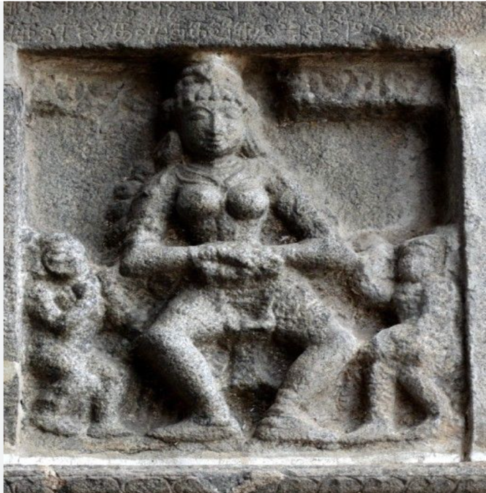 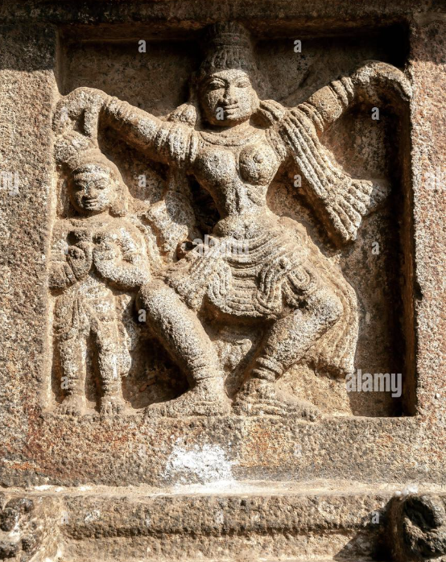

**Figure 29.** Chidambaram Temple of Nataraja, the Cosmic Dancer and a sculpt of a dancer performing

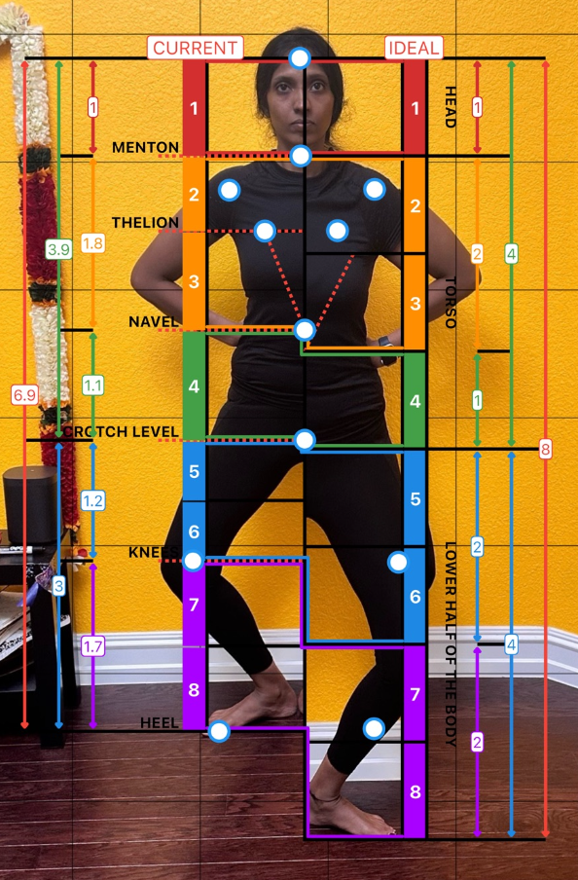

**Figure 30.** Analyzing Golden Ratio of Aramandi (Current) with Ideal posture (Standing)

Figure 30 shows the deviation of the body with Golden Ratio. If we follow the ancient text measurements, an Aramandi needs to be dipped 8 inches which is equal to the measurement from Index finger tip to end of the palm. This will be little less than the length of head or face approx. As we analyze the researcher body in figure 30, ideal body proportion should be ‘8’ heads proportion (measurement showed in the left side of the figure) while Aramandi posture is 6.9 proportion (measurement showed right side of the figure). Which means 8-~1=~7 which proves that the Aramandi/Kharvata/Aayata measurements are meticulously measure and designed in the ancient texts to extract the beauty in dance.

Note: The Golden Ratio is number that shows up all over the human body, from the length of the arms and legs compared to the torso, and it seems to define what proportions look best; that is, most attractive

**Challenges of Aramandi Technique** Aramandi is a very sensitive posture of the body. Also, this technique being the essential part of dance(kuchipudi), maintaining this posture throughout the dance piece, which can last several minutes, is particularly challenging. Even a small weight shift will eventually change the posture and loose it’s essence (as Jāyasenāpathi mentioned). Further, anatomically this posture is not natural (standing straight with feet in a natural, front-facing position) any miss alignments or in correct posture will lead to injuries.

If we follow the technicalities of Sauṣṭhavam and Kharvata/Aayata Mandala (as mentioned in Natyasastra, Nrutta Ratnavali, Abhinaya Darpana), we will achieve the posture. (Please note that, Figure 31 is near real posture with 99% accuracy)

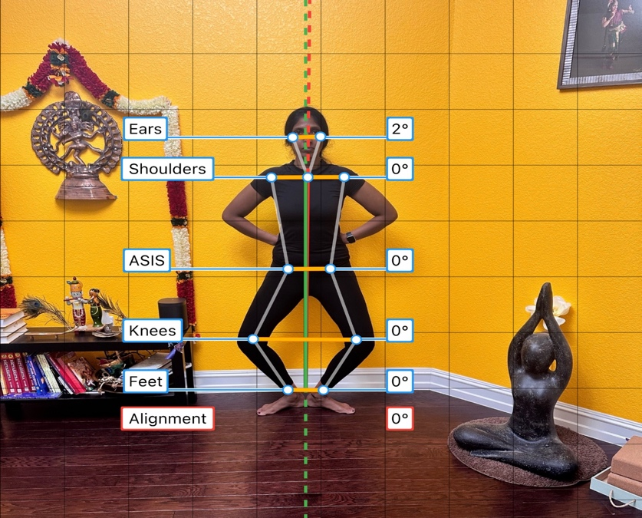

**Figure 31.** Aramandi by dipping 8 Angulas with heals touched and rotated including Thigs, Knee’s with hip, shoulders and ears alignment

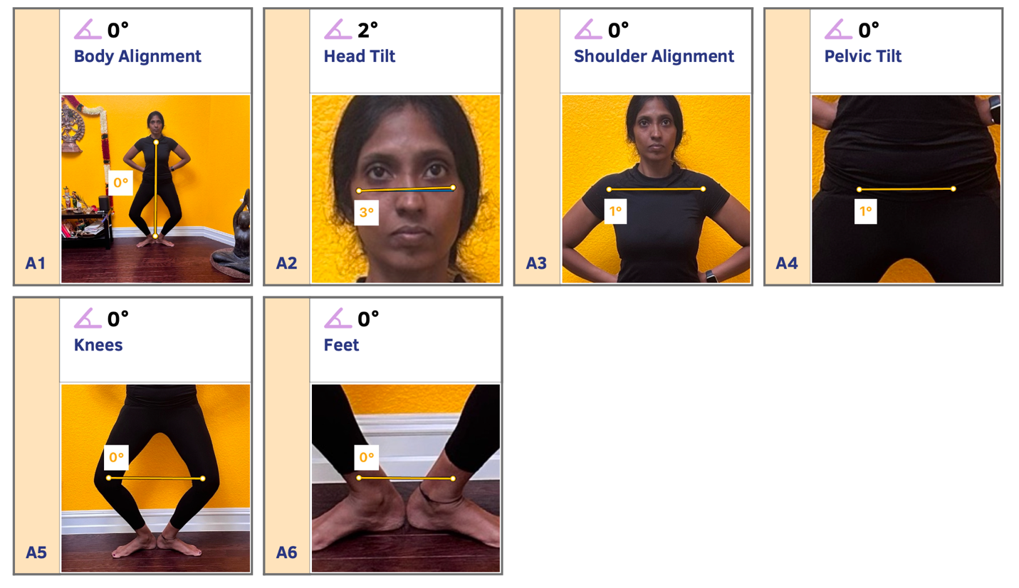

**Figure 32.** App results which show body alignments

Below figure shows how a small weight shift between foot result in miss alignment of the posture.

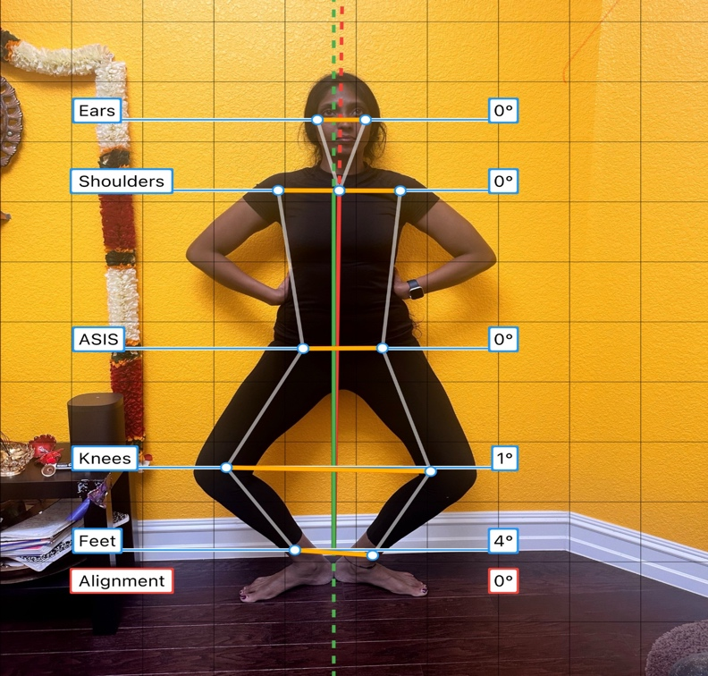

**Figure 33.** Aramandi with weight shift on right foot that effected the Knee alignment.

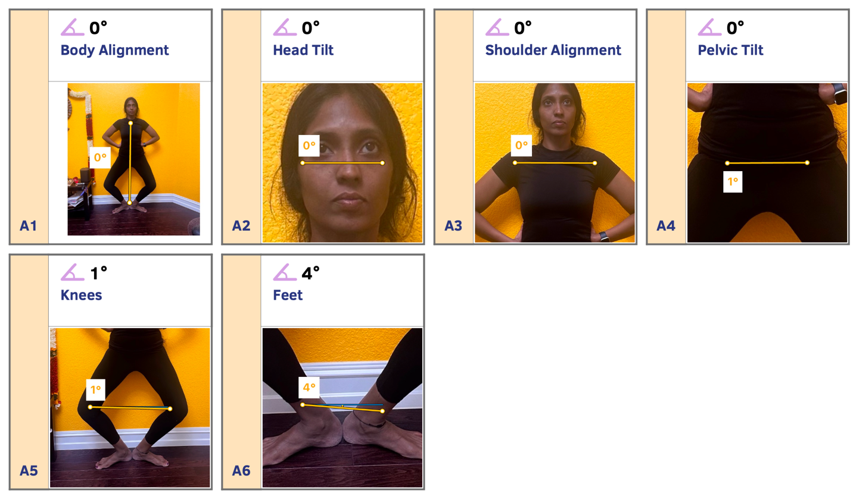

**Figure 34.** App results which show body Miss alignments

Anatomically, when a dancer shifts her weight onto her right foot, the alignment of the feet becomes imbalanced by 4 degrees. As a result, the knee is projected forward more than it should be, increasing the alignment angle by 1 degree. This means that the right knee is bearing more of the body's weight, putting pressure on the kneecaps and potentially leading to poor posture and a higher risk of knee injury.

**Anatomical Dissection of Aramandi for Yoga Integration** When examining the complete technique of Aramandi, each limb possesses its unique alignment, with further alignment required across multiple limbs. Hence, one needs to maintain flexibility throughout the body. However, it's not just about flexibility, it's also crucial to be mindful of movement and develop the stamina to sustain the posture. This involves consistent practice in activating the relevant muscle groups.



**Figure 35.** Head to toe, Different limb movements in different angles and alignments

In Figure 34, we can see the alignment involves Upper body which includes Head, Torso, hip and Lower Body which includes thighs, Knees and Heels. But overall, Spine is erected without any hunching.

Anatomical dissection of Aramandi as below:

* Scapular retraction at shoulder level

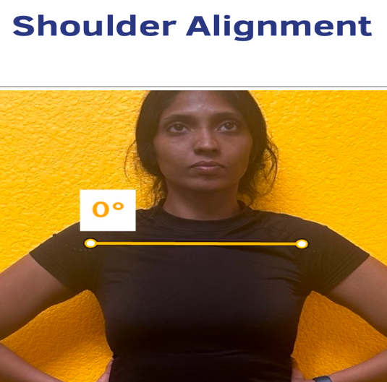

* Engagement of rectus abdominal muscle

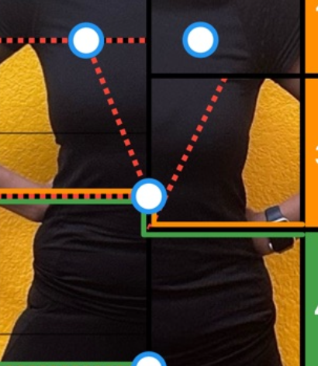

* Erector Spinae Muscles engagement

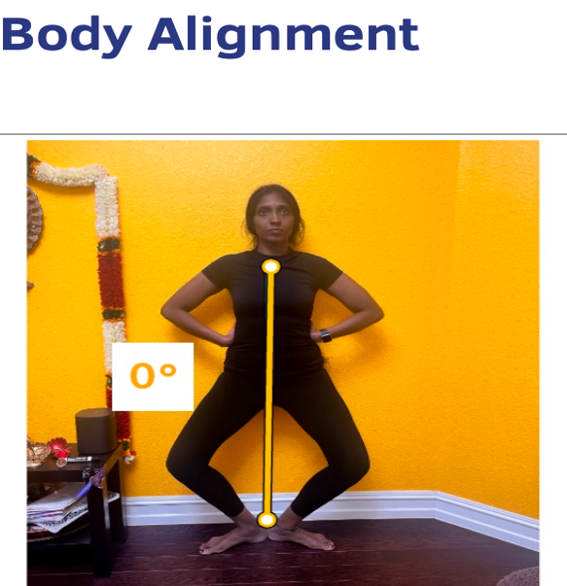

* Hip Flexors with external rotation

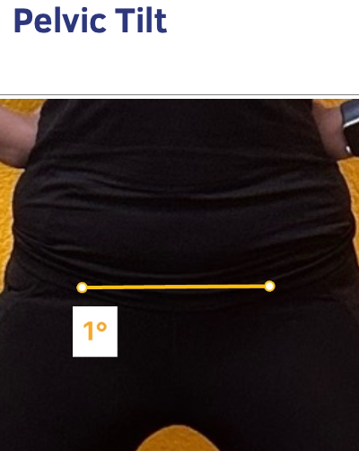

* Knee External Rotation

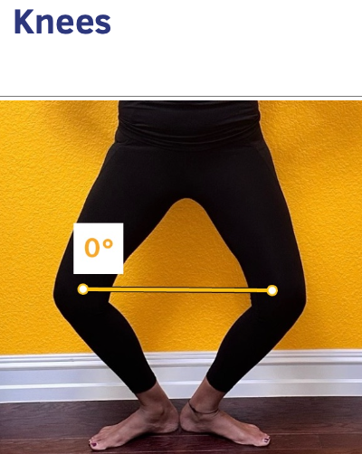

* Ankle Lateral Rotation

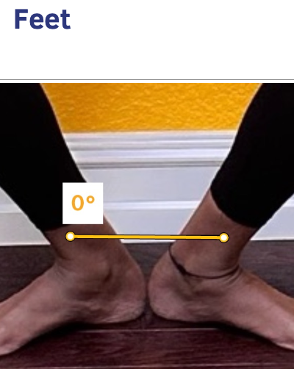

**Yoga Integration for Aramandi Technique** As we have observed, even a minor change in the body can significantly affect posture. This highlights the importance of self-awareness, a key principle in yoga known as "Embodiment and Presence". By utilizing yoga as a tool, we can enhance Aramandi, making dancers more comfortable and adapted to it naturally. This allows them to concentrate on the rest of the elements with greater ease and focus. It incorporates various asanas to enhance flexibility individually, followed by a slow-flowing sequence that ultimately improves Aramandi with stamina and reduces the risk of injury. However, it's essential to always remember that self and breath awareness and understanding one's body anatomy are key.

**Anatomy Name**: Scapular retraction at shoulder level

**Yoga Terminology**: Open or proud Chest with squeezed shoulder blade

**One of the Yoga Pose to achieve this**: Bhujangasana (COBRA POSE) and Bitilasana(COW POSE)

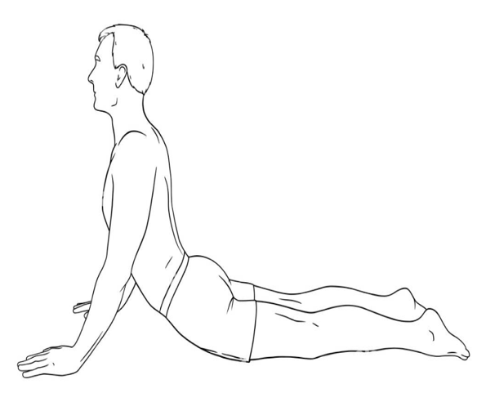 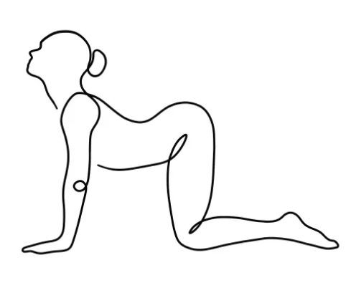

**Anatomy Name**: Engagement of rectus abdominal muscle

**Yoga Terminology**: Core Engagement

**One of the Yoga Pose to achieve this**: Chaturanga Dandasana (PLANK POSE)

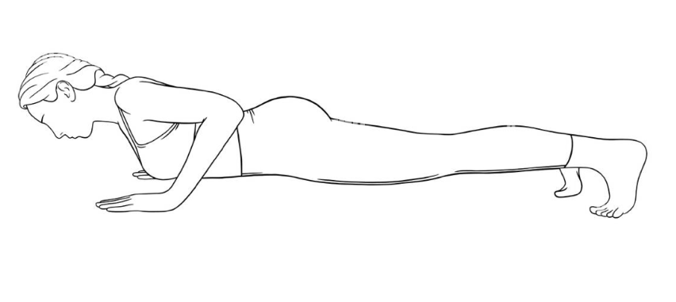

**Anatomy Name**: Erector Spinae Muscles engagement

**Yoga Terminology**: Core Engagement

**One of the Yoga Pose to achieve this**: Virabadrasana (WARRIOR POSE)

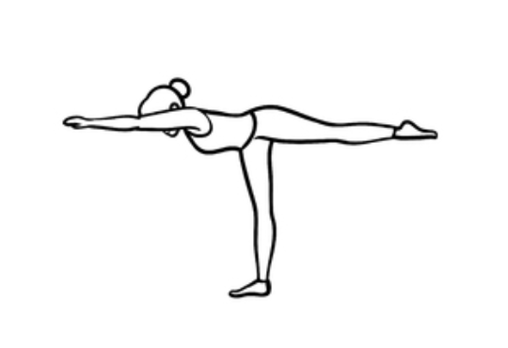

**Anatomy Name**: Hip Flexors with external rotation

**Yoga Terminology**: Hip Opening

**One of the Yoga Pose to achieve this**: Malasana (SQUAT POSE), Uttana Pristhasana(LIZARD POSE)

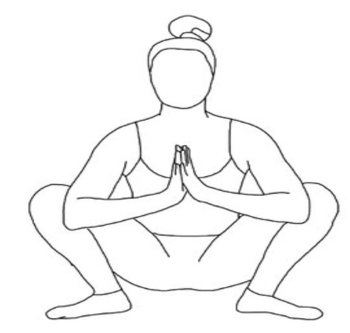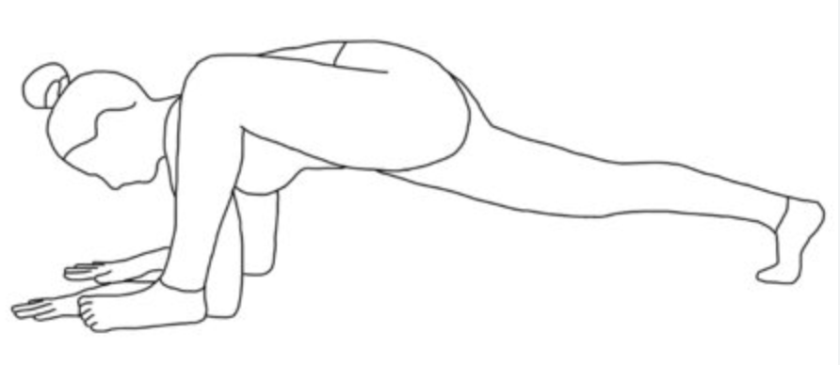

**Anatomy Name**: Knee External Rotation

**Yoga Terminology**: Knee Stability

**One of the Yoga Pose to achieve this**: Utkatasana (CHAIR POSE), Baddha Konasana(BOUND ANGLE POSE)

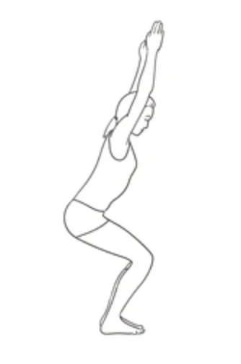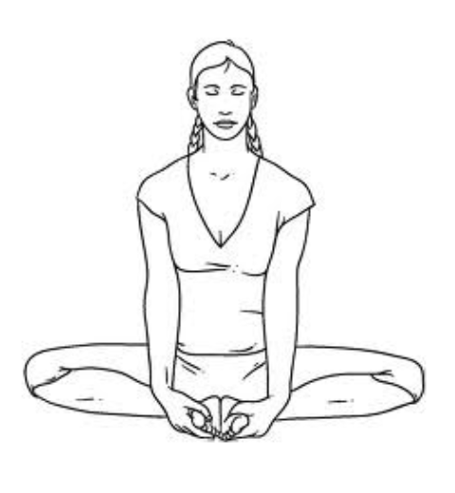

**Anatomy Name**: Ankle Lateral Rotation

**Yoga Terminology**: Angle the Foot

**One of the Yoga Pose to achieve this**: Utkata Konasana (GODESS POSE), Trikonasana (TRIANGLE POSE)

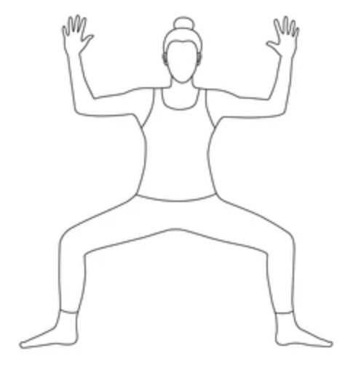 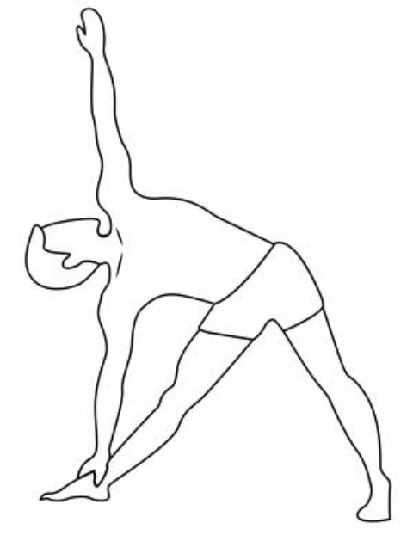

### **Case Studies on Performers' Experiences**

Case studies on performers experiences offers a unique opportunity to delve into the lived realities and insights of individuals immersed in the practice of yoga and Indian dance. By exploring the personal stories and experiences of performers, we gain invaluable insights into the transformative power of yoga and Indian dance, as well as the myriad challenges and triumphs encountered along the way.

As the researcher, several case studies sourced from various online journals and university studies have been examined, offering valuable insights for further exploration within the thesis. Below are the two among case studies

**Case Study 1**:

**Title**: Comparative study on flexibility among yoga and Bharatanatyam practicing student

**Researcher**: Dr. S Jagadeeswari

**Overview of Research**: In a comparative study, twenty Yoga practicing students from Peace and Cure Yoga Centre, Puducherry, were matched with twenty Bharatanatyam practicing students from Sri Saravanan Dance School, Puducherry, aged between 10 to 15. The flexibility of both groups was assessed using the 'V' sit reach test, while speed was measured by a 50-meter dash. Statistical analysis using the 't' test revealed a significant difference in flexibility between Yoga practicing students (YPS) and Bharatanatyam practicing students (BPS), with YPS demonstrating superior flexibility. This study underscores the potential benefits of Yoga practice in enhancing flexibility compared to Bharatanatyam training.

**Result**:

Table I displays the mean scores of Yoga and Bharatanatyam students, which were 101.2 and 83.35, respectively. The calculated 't' value for Yoga and Bharatanatyam students was 4.85, surpassing the required table value of 2.093 at a significance level of 0.05. This indicates a significant difference between the means of Group 1 and Group 2 at p<0.05. The calculated 't' value exceeds the critical value (4.8503 > 2.093), affirming the presence of a statistically significant difference.

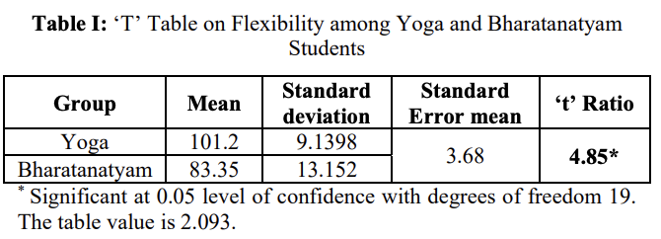

Illustration depicting the mean values of flexibility ('V' Sit Reach) among Yoga and Bharatanatyam students.

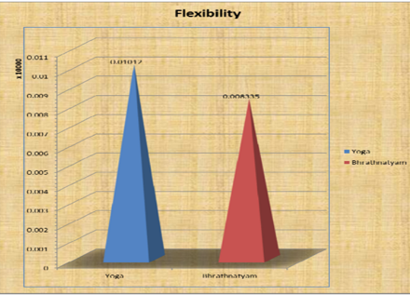

**Case Study 2**:

**Title**: Mindfulness and dance: the effect of yoga practice in college-aged dancers student

**Researcher**: Alison Saum

**Overview of Research**: This study explores the impact of increased mindfulness, facilitated by yoga practice, on the performance of college-aged dancers in classical ballet. Drawing upon previous research linking mindfulness practices, such as Pilates, to enhanced well-being in dancers, the study aims to fill a gap in understanding the effects of mindfulness within the classical ballet genre. Building on Adams et al.'s (2013) findings, which demonstrated improved mindfulness and decreased negative mood in Pilates participants, this research investigates how yoga, as a mindfulness technique, may similarly enhance self-regulation, reduce stress, and improve overall mind-body awareness among ballet dancers.

**Result**:

Table 2 presents the total FFMQ scores of the dancers over the duration of the study, along with the average FFMQ scores for the entire group. Overall, all dancers exhibited increases in total mindfulness from the pre-test to the mid-test questionnaire. However, during the mid- to final test questionnaire, three dancers showed decreases, while four demonstrated increases in mindfulness. The mean FFMQ scores indicate a collective increase in mindfulness among the group of dancers.

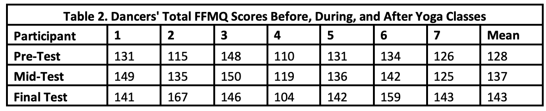

### **Why to integrate yoga techniques to dance?**

As a researcher, the observation from real world is, the lifestyles of professional dancers and serious yoga practitioners diverge significantly. While there is no equivalent of a professional yogi, the yogic individual is typically mindful, striving to promote love and peace. They prioritize listening to their bodies and letting their breath guide their movement, aiming for a meditative state through disciplined practice. Their focus is on inward growth and becoming the serene observer. Conversely, dancers operate in a more stressful environment, driven by competition and the constant presence of anxiety. They prioritize flexibility, strength, and physical conditioning to excel in their performances. The competitive nature of professional dance often leads to issues of low self-esteem and fatigue due to rigorous training schedules.

Due to their focus on tension and anxiety relief methods, yogis experience fewer injuries compared to dancers. Dancers face similar physical demands as athletes, leading to injuries related to movement and impact. The injuries sustained in dance and the measures taken for treatment, rehabilitation, and prevention closely resemble those encountered in sports. This highlights the need to integrate yoga into dance practice, as yoga offers a lifelong journey focused on inward growth and can serve as a valuable tool for dancers, providing them with techniques to manage stress, enhance body awareness, and prevent injuries, ultimately enhancing their overall performance and well-being.

## **Chapter 2.4: Data Collection – Quantitative Analysis**

# **References**

Teachers, M. by. (n.d.). *Dance is*. Www.markedbyteachers.com. Retrieved March 10, 2024, from <https://www.markedbyteachers.com/as-and-a-level/music/dance-is-rhythmic-and-expressive-body-movement-usually-coordinated-into-a-pattern-and-performed-with-music.html>

*Style And Technique of Kuchipudi*. (n.d.). IndiaNetzone.com. Retrieved March 10, 2024, from <https://www.indianetzone.com/18/style_technique_kuchipudi.htm>

Team, S. (2023, August 16). *Kuchipudi: Graceful Narratives in Motion*. Serenade. <https://india.serenademagazine.com/dance/kuchipudi-graceful-narratives-in-motion/>

Gingrich, D. M. (2022, January 27). *A Comprehensive View of Kuchipudi*. Saathee Magazine. <https://saathee.com/a-comprehensive-view-of-kuchipudi/>

*Kuchipudi flourished as a dramatic form of dance for hundreds of years*. (n.d.). Www.hindustaniclassical.com. Retrieved March 10, 2024, from <http://www.hindustaniclassical.com/dances/kuchipudi>

*Classes – Raagaleena Dance Academy*. (n.d.). Retrieved March 10, 2024, from <https://www.raagaleena.org/classes/>

*Kuchipudi - Jessica Heinonen*. (n.d.). Cargocollective.com. Retrieved March 10, 2024, from <https://cargocollective.com/Jessicaheinonen/Kuchipudi>

*Sausthava*. (n.d.). Sreenivasarao’s Blogs. Retrieved March 10, 2024, from <https://sreenivasaraos.com/tag/sausthava/>

Dr Padma Subrahmanyam. (2010). *Bharatiya Natyashastra, Vol. 1*. Internet Archive. <https://archive.org/details/dli.pb.natyashastra.1/Natyashastra.1_1.m4v>

Bharata. Natya Sastra: Bharatamuni Praneetam Natya Sastram, translated by Sriramachandrudu, Pullela. Samantha Graphics, first edition, Hyderabad, 2014, pp. 189,190

Rad, A. (2023, July 20). *Types of Movements in the Human Body*. Kenhub. <https://www.kenhub.com/en/library/anatomy/types-of-movements-in-the-human-body>

*Introductory Exploration of Anatomy in Motion*. (n.d.). The Body Lab. Retrieved March 10, 2024, from <https://www.thebodylab.au/lab-blog/introductory-exploration-of-anatomy-in-motion>

*Types of Body Movements | Anatomy and Physiology I*. (n.d.). Courses.lumenlearning.com. <https://courses.lumenlearning.com/suny-ap1/chapter/types-of-body-movements/>

Ananya. (2019, January 4). *Head And Neck Movements In Bharatanatyam*. Little Banyan Tree Kids. <https://littlebanyantreekids.wordpress.com/2019/01/04/head-and-neck-movements-in-bharatanatyam/>

*Integrated thoughts*. (n.d.). Deepikasingh89.Blogspot.com. Retrieved March 10, 2024, from <https://deepikasingh89.blogspot.com/2013/08/>

*www.Kuchipudi.com | Kuchipudi art Academy» Akasiki Charis*. (2024). Kuchipudi.com. <https://www.kuchipudi.com/grammar/kapittha/>

Jones, O. (2020, May 30). *Anatomical Terms of Movement - Flexion - Rotation - TeachMeAnatomy*. Teachmeanatomy.info. <https://teachmeanatomy.info/the-basics/anatomical-terminology/terms-of-movement/>

*The Divine Dance*. (2007, August 28). Yoga Journal. <https://www.yogajournal.com/lifestyle/balance/the-divine-dance/>

*What Is a Theoretical Framework? (Plus Example)*. (n.d.). Indeed Career Guide. <https://www.indeed.com/career-advice/career-development/theoretical-framework>

Vinz, S. (2022, October 14). *The Theoretical Framework: What and How? | A Quick Guide*. Scribbr. <https://www.scribbr.com/dissertation/theoretical-framework/>

University of Southern California. (2013). *Research Guides: Organizing Your Social Sciences Research Paper: Theoretical Framework*. Usc.edu; University of Southern California. <https://libguides.usc.edu/writingguide/theoreticalframework>

Digitalcommons@lesley, D. (n.d.). <https://digitalcommons.lesley.edu/cgi/viewcontent.cgi?article=1236&context=expressive_theses>

Tandon, R. (n.d.). The Symbiotic Relationship between Indian Dance and the Yogic Chakras. *Www.academia.edu*. Retrieved March 10, 2024, from <https://www.academia.edu/5142404/The_Symbiotic_Relationship_between_Indian_Dance_and_the_Yogic_Chakras>

<http://groups.csail.mit.edu/medg/people/fern/yoga%20thesis%20complete.pdf>

Shiota, S., & Nomura, M. (2018, November 5). *Dynamic and Static Models of Body-Mind Approaches from Neurobiological Perspectives*. Www.intechopen.com; IntechOpen. <https://www.intechopen.com/chapters/63761>

Hately, S. (2017, January 11). *Anatomy and Asana: Warrior 1 | Functional Synergy*. <https://www.functionalsynergy.com/anatomy-asana-warrior-1/>

psyjdc. (2020, October 16). *Yoga Changes the Brain to Improve Body Awareness, Attention, and Present Moment Awareness*. Contemplative Studies. <http://contemplative-studies.org/wp/index.php/2020/10/16/yoga-changes-the-brain-to-improve-body-awareness-attention-and-present-moment-awareness/>

TRAINING, O. Y. S. Y. T. (2019, March 21). *How To Distinguish Differences in Tension and Compression in Yoga*. <https://www.stephmitchellyoga.com/2019/03/how-to-distinguish-differences-in.html>

Wiese, C. (2021, April 20). *Muscle Contraction In Yoga: A Deeper Understanding*. Yoganatomy. <https://www.yoganatomy.com/muscle-contraction-in-yoga/>

Jagadeeswari, S. (2017). Comparative study on flexibility among yoga and Bharatanatyam practicing student. *~ 1 ~ International Journal of Physical Education, Sports and Health*, *4*(4). <https://www.kheljournal.com/archives/2017/vol4issue4/PartA/4-3-132-243.pdf>

Saum, Alison, "Mindfulness and Dance: The Effect of Yoga Practices in College-Aged Dancers" (2017). Senior Theses. 190. <https://scholarcommons.sc.edu/senior_theses/190>

<https://groups.csail.mit.edu/medg/people/fern/yoga%20thesis%20complete.pdf>

Lim, S. (2019, October 21). *What Body Proportion Look Best | The Golden Ratio*. Medium. <https://medium.com/@shurenlim/what-body-proportion-look-best-the-golden-ratio-c332ee8c8882>

Srikanth, R. (2020, July 23). The araimandi debate in Bharatanatyam. *The Hindu*. <https://www.thehindu.com/entertainment/dance/the-araimandi-debate-in-bharatanatyam/article32173863.ece>

Jāyasenāpati, Pappu Vēṇugōpāla Rāvu, Yashoda Thakore, & India. (2013). *Nr̥tta ratnāvalī of Jāya Senāpati*. Kakatiya Heritage Trust.

The Journal of Music Academy of Madras. (1961).

Nandikeśvara, & Apparao, P. S. R. (1997). *Abhinaya darpaṇam of Nandikeśwara*. P.S.R. Appa Rao.